AP Table of Contents
AP Table of Contents 1
AP Icons 2
AP Icons Overview 2
AP Operations 3
AP Operations Overview 3
Accounts Payable 5
Invoice Entry 6
Invoice Register 15
Payment Selection 19
Payment Selection Report 23
Check Printing 25
Check Register 30
Manual Check Entry 33
Manual Check Register 41
AP Aging Report 44
Cash Requirements Report 48
Accounts Payable Reports 51
Vendor Label Printing 54
Vendor Detail Listing 57
Vendor Comments Listing 60
Vendor Name and Address Listing 62
Vendor Ledger Cards 65
Period End Processing Menu 69
Purchase Journal 72
Disbursements Journal 76
Monthly Check Report 80
Period End Update 82
AP Form 1099 Data Export 83
Close Form 1099 Year 85
Accounts Payable Maintenance 86
Vendor Maintenance 89
Accounts Payable Type Maintenance 112
Distribution Code Maintenance 115
Payment Group Maintenance 118
Terms Code Maintenance 121
Buyer Code Maintenance 124
Recurring Invoice Entry 127
Recurring Invoice Register 129
Parameter Maintenance 133
Application Parameters 135
Report Parameters 140

AP Icons

AP Icons Overview

The following navigation and operation icons are used throughout this documentation. Refer to this list for descriptions and keyboard equivalents.

 | New – clears the current form in order to enter new data. | Ctrl+N
 | Add to end – used in grid entry to add a new record after the last current row. | Ctrl+A
 | Insert before – used in grid entry to insert a new record before the currently selected row. | Ctrl+Shift+A
 | Delete current record – if focused in header portion of header/detail form, prompts for deletion of header and all detail; if focused in a detail grid, deletes current row. | Alt+Del
 | Save current record – saves current record in a grid, or header and all detail records if in a header/detail form. | Ctrl+S
 | Refresh data – refreshes current display. | Alt+F5
 | Run process – used in Options Entry forms after selections have been made to run the associated program. | F5
 | Print current record – prints the currently displayed record to the Document Output window | Ctrl+P
 | First record – navigates to the first record in a table when in Maintenance Grid mode. | Alt+Page Up
 | Previous record - navigates to the previous record in a table when in Maintenance Grid mode. | Page Up
 | Next record - navigates to the next record in a table when in Maintenance Grid mode. | Page Down
 | Last record – navigates to the last record in a table when in Maintenance Grid mode. | Alt+Page Down
 | Record Query - Invokes the inquiry subsystem to view records from the table associated with a form. | Ctrl+Q
 | Find – used to display a list of candidate records when in a validated field. | Ctrl+F
 | Expand record – used to display full contents of the record underlying a validated field. | Ctrl+E
 | Calendar – launches a graphical calendar for use in date fields. | Ctrl+L
 | Launch link – launches the specified URL
 | Drilldown – launches a user-specified drilldown definition. | Ctrl+D
 | Options – dropdown menu containing optional processes, such as subsidiary forms or reports. | Ctrl+O
 | Close – closes the active window. | Ctrl+F4

AP Operations

AP Operations Overview

The Operations section contains descriptions of the Accounts Payable tasks. A sample of each screen is shown. Each field is described, and the operation of each task is explained. Examples of each report and register are also provided. Use this section as a reference when using the Accounts Payable menu options.

The tasks in this section are organized according to appearance on the menu in a standard installation of the software. Because you can customize AddonSoftware menus, the appearance and function of your Accounts Payable module may vary slightly from the descriptions in the manual. For instructions on how to use menus in the AddonSoftware system, refer to the AddonSoftware Administrator manual.

About the Accounts Payable Tasks
Tasks in Accounts Payable are grouped into areas of operation. Common tasks such as invoice or check entries are stand-alone tasks that are accessed directly from the main menu; tasks that work in concert with one another such as period-end processing tasks or maintenance tasks are accessed through a sub-menu off the main menu.

In addition, some tasks have several options for complete processing. For example, you can use the Vendor Maintenance task to access vendor detail information and inquire about purchase history or open invoices. These processes are selectable from an option menu.

Accounts Payable
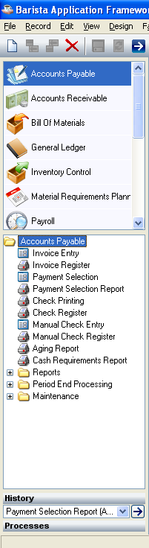
Accounts Payable Menu

Function
The Accounts Payable Main Menu provides access to all the tasks in the Accounts Payable module, including those in the Period End Processing and Accounts Payable Maintenance menus.

■ To access this menu...

Select Accounts Payable from the AddonSoftware Main Menu.

Invoice Entry
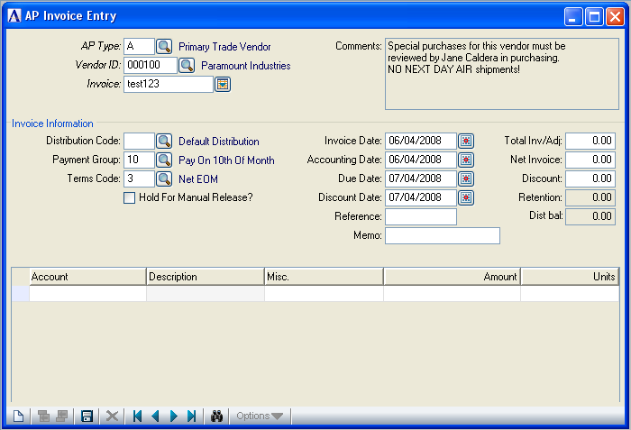
Invoice Entry

Function
This task is used to enter new vendor invoices and adjust previously entered invoices. If the Purchase Order module is installed, use this task only for invoices without a purchase order assignment such as rent, utilities, etc. To enter some invoice information, you will need to use codes. For information about the use of accounts payable type codes, distribution codes, and payment group codes, refer to the Parameter Maintenance task.

■ To access this task...

Select Invoice Entry from the Accounts Payable Processing Menu.

About the Fields
Invoice Entry is a Header/Detail form. At the top of the form, enter the AP Type, Vendor ID and Invoice Number. In the Invoice Information section, enter information about the invoice terms, dates and invoice amount. In the lower section fields, enter the expense or purchase distribution detail to the general ledger.

When you first access this task, you will be presented with an Option Entry screen:

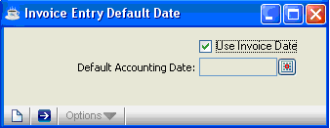

• Leave the Use Invoice Date checkbox checked to use the invoice date as a default for the accounting date. The accounting date is the date the invoice will be posted to the general ledger (if it is installed).
- Uncheck the Use Invoice Date checkbox and enter a valid date. This date must fall in an open general ledger period.

When you have selected the desired option,

- Click the Run Process button to accept the selections and run the main form
- Click the Close Window button to return to the Accounts Payable Processing Menu.

The invoice date defaults to the current date. The default for the due date and discount date is calculated based on terms code for an invoice and invoice date. If you opted to Use Invoice Date above, then when the invoice date is changed, the accounting date defaults to match. However, if you enter a Default Accounting Date, then the accounting date does not change as invoice date is changed.

When the General Ledger module is installed, the accounting date of an invoice is used as the transaction date for general ledger postings. Use the same accounting date for a group of invoices so that they are summarized together. You can override the default accounting date for each invoice and replace it with the date appearing on the invoice in order to generate General Ledger transactions with multiple dates.

In the AP Type field...
This field is accessible when the Multiple AP Types field in Parameter Maintenance is set to Y.
- Enter a valid accounts payable type code.
- Click the Find button to select from a list of existing type codes associated with this vendor.

NOTE: A valid accounts payable type is one that is defined in the Accounts Payable Type Maintenance task and assigned to the vendor in the Detail Information option of the Vendor Maintenance task.

In the Vendor ID field...
- Enter a valid vendor number.
- Click the Find button to select from a list of existing vendor numbers.

If you select a valid vendor number, the name and comments associated with the vendor are displayed.

In the Invoice No field...
• Enter from 1 to 10 characters (Alphanumeric).

When you enter an invoice number that is already associated with a vendor, the invoice date and amount is displayed to the right of the invoice number, and the Distribution Code, Invoice Date and Net invoice fields will not be editable. In this mode, you are creating an adjustment to an existing invoice (an invoice that has been entered and updated, but is not yet fully paid).

In the Distribution Code field...
This field is accessible when the Multiple Distribution Types field in Parameter Maintenance is set to Y
- Enter a valid distribution code.
- Click the Find button to select from a list of existing distribution codes

The distribution code determines the Accounts Payable account where invoice amounts are recorded when the invoice is updated, and the cash and discounts accounts to use when invoices are paid.

In the Payment Group field...
- Enter a valid payment group.
- Click the Find button to select from a list of existing payment group codes

The payment group provides a way to group invoices for payment selection and is used by the Payment Selection task.

In the Terms Code field...
- Enter a valid terms code.
- Click the Find button to select from a list of existing terms codes

The terms code determines the default due date, discount date, and percentage of available discount (if applicable) for the invoice.
In the Hold for Manual Release field...
- Check the Hold for Manual Release box to withhold the invoice from automatic payment selection.
- Uncheck the Hold for Manual Release box to include the invoice for automatic payment selection.

Invoices put on hold during invoice entry can be selected for payment during the Payment Selection task by selecting the Select by Specific Invoices option.

In the Invoice Date field...
- Enter the invoice date from the vendor’s invoice. The current date is default for this field
- Click the Calendar button to select a date by using the calendar tool.

The default due date and discount dates are calculated from the terms code assigned to the invoice; however, these dates can be individually overridden. Also, if you opted to use Invoice Date at the opening screen, Accounting Date defaults to Invoice Date.

In the Accounting Date field...
- Enter an accounting date.
- Click the Calendar button to select a date by using the calendar tool.

This date is assigned for posting to the general ledger during the Invoice Register Update process.

NOTE: When the Post to Closed Periods parameter is set to Y, you can override the date to fall in a closed general ledger period.

In the Due Date field...
- Enter a due date. The default invoice due date is based on the invoice date and the terms code.
- Click the Calendar button to select a date by using the calendar tool.

The invoice due date is used by the Aging Report, the Cash Requirements Report, and the Payment Selection task.

In the Discount Date field...
- Enter a date through which the invoice is eligible for a discount. The default discount date is based on the invoice date and terms code.
- Click the Calendar button to select a date by using the calendar tool.

In the Total Inv/Adj field...
- Enter the total invoice amount (new invoice).
- Enter the amount of Adjustment if the invoice was previously entered for this vendor and AP type, and is not fully paid.

The total Invoice amount must equal the sum that is distributed to the general ledger. Be sure that the total invoice amount accurately reflects the amount on the invoice, regardless of the receiving record.

The Total Invoice Amount and Net Invoice Amount fields are not accessible for adjustments.

The adjustment amount is the amount the original invoice is to be changed and is entered as either a positive amount (to increase the invoice amount) or as a negative amount (to reduce the invoice amount). Receiving a credit memo is one example of when an adjustment amount would be entered for an invoice.

Adjustment Amount Example
An invoice for $100 was previously entered (and updated) and is to be adjusted to $95 dollars. Enter -5 in the Tot Inv/Adj field to reduce the invoice to the correct amount (100 – 5 = 95).

In the Net Invoice Amt field...
- Enter the amount of the invoice that is eligible for discount, if offered by the vendor.

This amount is used to calculate the available discount, based on the terms code.

In the Discount Amt field...
- Enter the amount of discount or accept the default.

In the Retention Amt field...
This field is enabled only when the Retention Account parameter is set to Y.
• Enter the retention amount that is to be withheld from the invoice payment during the payment selection process.

When retention is used, the amount of the retention is posted (credited) to the retention payable account defined in the distribution code that is associated with the invoice, and the standard accounts payable account is posted with the difference.

In the Dist Bal field...
Display Only. This field is not available for editing. As the distribution amounts are entered, total invoice amount minus total distribution amount will be displayed in this field.

In the Reference field...
• Enter an optional reference number or comment of 1 to 10 characters in length.

A reference such as a shipping document number can be associated with the invoice and printed on the Invoice Register.

In the Memo field...
• Enter additional descriptive information of 1 to 16 characters in length.

When the Print Memo On Check Stub parameter is set to Y, this memo is printed on the check stub next to the amount paid. In addition, the memo prints on the Invoice Register.

When you finish making entries in the header section, the enter distribution detail lines in the detail grid.

Invoice Distribution
For each invoice, specify the invoice distribution in the detail section. When the General Ledger module is installed, these distributions consist of debit postings for the invoice and specifying the account(s) for purchase expense, freight, tax, work in process, or inventory purchases. The credit posting to the accounts payable account (assuming the Cash Basis parameter is not set to Y) is supplied by the accounts payable distribution code associated with the invoice. This code is either the standard default distribution code of “ ”(when the Multiple Distributions parameter is set to N) or assigned individually to each invoice (when the Multiple Distributions parameter is set to Y).

For each detail distribution line, general ledger account (when General Ledger is installed), and distribution amount is entered, up to 99 distributions for each invoice. If the Miscellaneous Entry parameter is Y, a miscellaneous field is also available for a 10-character comment.

There can be one or more distribution lines for each invoice, depending on how the distribution of the invoice amount is made. Enter distributions until the total of the amounts on the distribution lines equals the total invoice amount. The remaining amount of the invoice to be distributed (distribution balance) is shown in the Dist Bal field as each line is entered.

If the General Ledger module is not installed, the distribution section is not accessible and distribution cannot be made.

In the Account field...
This field is accessible only when the General Ledger module is installed.
• Enter a valid general ledger account for the debit distribution.
-or-
Click the Find button from the menu bar to select from a list of existing accounts.

In the Description field...
Display Only. The GL account description is displayed in this field.

In the Miscellaneous field...
This field appears only when the Miscellaneous Entry parameter is set to Y.
• Enter additional information about the account.

In the Amount field...
• Enter the amount of the distribution.

Normally only the debit side of the entry is entered, and the credit side is supplied automatically during the Invoice Register Update from the distribution code associated with the invoice. A positive amount results in a debit posting to the account during the Invoice Register Update process. A negative amount results in a credit posting.

In the Units field...
This field is accessible only when the General Ledger module is installed and the Use Units parameter in General Ledger is set to Y.
• Enter the number of units associated with the distribution line.

Units are used to track and report nondollar quantities in the General Ledger module. The units need not balance against a control number in the invoice header.

While in the detail grid, use the Enter key to toggle between navigation mode and edit mode in a given cell. In navigation mode, the cell has a dotted outline. In edit mode, the contents of the cell are selected.

While in edit mode
• Use the Enter key to accept the edits and remain in the cell, toggling to navigation mode
- Use the Tab key to accept the edits and move to the next cell

While in navigation mode
- Use the Enter key to highlight the contents of the cell and perform edits (i.e., toggles to edit mode)
- Use the arrow or tab keys to move to different cells

In either edit or navigation mode
- Use the F7 key to toggle between the header and detail grid portions of the form
- Click the Delete buttonto delete the current line. Note: if the focus is in the header portion of the form rather than the detail grid, clicking the Delete button will delete the header and all associated detail. A confirmation message box will be issued in this event.
- Click the Save button to save the header and all detail records. The form is cleared in preparation for a new entry.
- Click the New button to begin a new invoice entry
- Click the Close Window button to return to the Accounts Payable Processing Menu.

If you attempt to leave an unsaved invoice by clicking New or Close Window, the module will issue a confirmation box as follows:

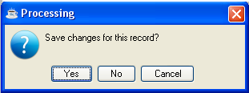

- Click Yes to save the current record and return to Accounts Payable Processing Menu.
- Click No to return to the Accounts Payable Processing Menu without saving the current record.
- Click Cancel or click the Close Window button to return to the current Invoice Entry Screen

When you attempt to save an invoice, the total invoice amount (or adjustment amount) is compared to the total distributions. When it is out of balance, the module issues the prompt:

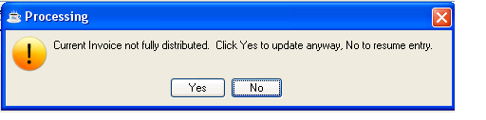

• Press Yes to write the invoice in the entry file, or No to return to the entry screen and correct the imbalance. Note that you will not be permitted to update the invoice register if you have invoices out of balance.

Adjusting an Invoice
Once an invoice is entered and updated, you can change most invoice information only by making an adjustment. Receiving a credit memo from a vendor is one example of when adjusting an invoice would be necessary. The AddonSoftware Accounts Payable procedures for adjusting an open invoice follow generally accepted accounting practice.

Adjusting Discount and Retention Amounts
To change the discount amount and/or retention amount of an invoice, enter an amount in the Discount Amount and/or Retention Amount field (depending on the one that is to be adjusted) that reflects the amount of the change.

Discount Adjustment Example
Increase the discount amount of an invoice from $10 to $30 by entering a discount amount of 20.

Adjusting Net Invoices
The net invoice amount is changed by entering an adjustment figure that reflects how much the Net Invoice Amount field should be changed.

Net Invoice Adjustment Example
To reduce the net invoice amount of an invoice from $100 to $90, enter an adjustment amount of -10. Enter the distribution information in the detail section according to previous instructions.

Adjusting Dates and Purchase Order Numbers
To change the accounting date, receipt date and/or purchase order number, you must adjust the invoice to zero, update it, reenter it with the correct information and update it again.

Date Adjustment Example
Enter an adjustment amount that is -1 times the original net invoice amount, thereby adjusting the balance to zero. Reverse the detail distribution lines, then print and update the Invoice Register. Re-enter the invoice with the correct information. Print and update the register again.

To change the due date and/or discount date, enter the revised date(s) in the appropriate field(s) and enter an adjustment amount of zero. Print and update the Invoice Register.

Invoice Register

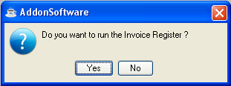
Invoice Register

Function
Use the Invoice Register to review the entries made in the Invoice Entry task before updating the permanent files. The register also lists recurring invoices updated from the Recurring Invoice Register.

■ To access this task...

Select Invoice Register from the Accounts Payable Processing Menu.

- Click Yes to run the register,
- Click No or the Close Window button to return to the Accounts Payable Processing Menu
When the General Ledger module is installed and the GL Posting parameter is set to Y, the final page of the Invoice Register is a recap of all the general ledger postings, in account number order, which will be made during the Invoice Register Update process.

Printing
The Invoice Register will appear in the Document Output Display window. Select your desired output format and click the Create button:

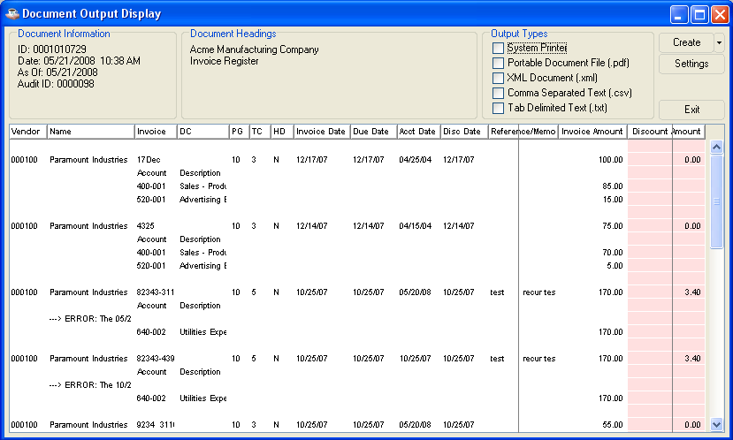

Any data shaded with pink in the Document Output window is at risk of truncation when the document is printed or saved in pdf format. Click and drag to adjust column sizes until no pink shading remains. If the report is too large to adjust in this manner, save it in one of the disk file formats (xml, cxv, txt) in order to prevent data loss.

Choose your Output Type and click the Create button. After the file is created or printed, click the Close Window button to close the Document Output Display window.

If you left any invoices not fully distributed, or other errors are detected in the register, you’ll see the warning:

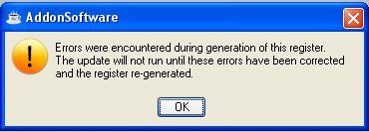
In this case, you will not be permitted to update the invoices until you’ve returned to Invoice Entry to make corrections, and reproduced the Invoice Register.

Otherwise, if General Ledger is installed and the GL Posting Parameter is set to Y, you’ll be presented with a second Document Output Display window. This GL recap lists general ledger postings, in account number order, created during the Invoice Register. If the GL Recap report detects any other errors, the same error message as above reappears.

As with the register, choose your Output Type and click the Create button. After the file is created or printed, click the Close Window button or press ctl-F4 to close the Document Output Display window.

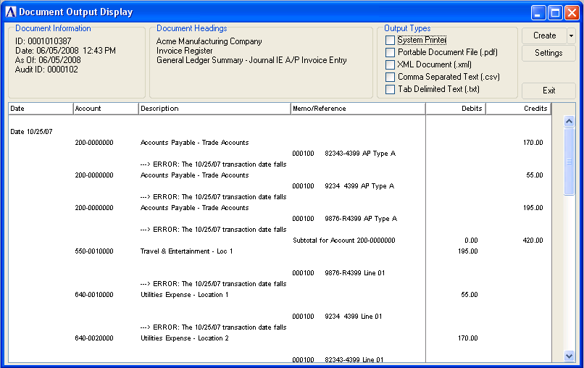

When the printing is completed, and there are no errors, the module issues a confirmation box:

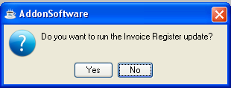

- Click Yes when the register was printed correctly and it balances to the totals for entered invoices.
- Click No or the Close Window button to return to the Account Payable Processing Menu if the invoice information must be changed because it is not correct.

NOTE: Since the original invoice information cannot be changed through Invoice Entry after updating the Invoice Register (other than making an adjustment entry), be sure that the information is correct before proceeding.

Updating

Invoices or adjustments that you entered during the invoice entry process are added to the Accounts Payable Open Invoice file. The updated invoice information is also added to the vendor history, and when the General Ledger module is installed, postings are made to the General Ledger Daily Detail file.

Payment Selection
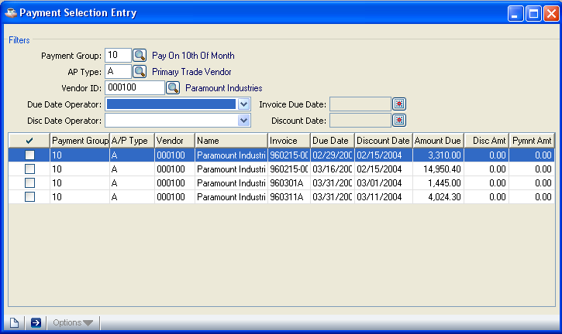
Payment Selection

Function
Use this task to automatically, manually, or semi-automatically select invoices for payment. The first step in paying open invoices is to select the invoices to be paid. You can use the Aging Report, a list of aged open invoices, to determine what invoices should be paid for each vendor. The Cash Requirements Report provides you a projection of invoices coming due.

■ To access this task...

Select Payment Selection from the Accounts Payable Processing Menu.
The module issues the following prompt before the selection menu appears if prior selections are made in this task and checks are not written:

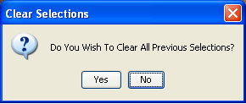

- Click Yes to remove all the previous selections. (To see what invoices were selected for payment, print the Payment Selection Report.)
- Click No or click the close window button to retain the previous selections.

If check printing has started and the update is not complete, the module issues the following warning:

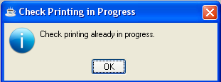

• Click OK to access the Accounts Payable Processing Menu again. You cannot change the payment selection options until the check printing and Check Register Update is complete.

Selecting a Payment
When you enter this task, an Option Entry form will be presented which contains filters that show the ways that invoices can be selected for payment from the Open Invoice file. You can use any combination of these selections to select (or deselect) the invoices to be paid. The selected invoice details will be displayed in the grid.

In the Payment Group field...
- Enter the payment group desired. The description of the payment group is displayed.
- Click the Find button to select from a list of existing payment groups.

In the AP Type field...
- Enter the accounts payable type to select for payment. Open invoices with the specified accounts payable type are selected for payment.
- Click the Find button to select from a list of existing accounts payable types.

In the Vendor ID field...
If the vendor is on hold, a message will display on the screen.
- Enter a valid vendor number. The vendor’s name is displayed.
- Click the Find button to select from a list of existing vendor numbers.

In the Due Date Operator field...
- Select any operator like: less than, equal to, greater than, less than/equal to, greater than/equal to, not equal to from the drop down box.

In the Invoice Due Date field...
- Enter the invoice due date to be included in the selection process
- Click the Calendar button to select a due date using the calendar tool

In the Disc Date Operator field...
• Select any operator like: less than, equal to, greater than, less than/equal to, greater than/equal to, not equal to from the drop down box

In the Discount Date field...
- Enter the discount due date to be included in the selection process
- Click the Calendar button to select a discount date using the calendar tool

The due, discount, and payment amounts for the selected invoice are displayed. The due amount is the remaining balance owed on the invoice. The discount amount is the standard discount that remains to be taken and can be accepted as is or changed. You can adjust the payment amount by overriding the due and discount amounts. The amount paid on the check is shown in the Payment Amount field. It is calculated as the due minus the discount.

Payment Selection Report
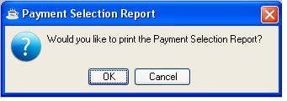
Payment Selection Report

Function
Use this report to review payment selections before printing checks. The report displays calculated check amounts for each vendor selected for payment. If there is more than one invoice for an AP type/vendor combination, the invoices are grouped together. The subtotal of the invoices on the check will be printed. If a vendor has multiple invoices for multiple AP types, those invoices will appear on different pages of the report, (ie. The vendor will be listed multiple times). Also, multiple checks will be produced for that vendor. The payment total of the report is the total amount to be disbursed.

■ To access this task...

Select Payment Selection Report from the Accounts Payable Processing Menu.

- Click OK to print the Check Selection Register.
- Click Cancel or the Close Window button to return to the Accounts Payable Processing Menu
When any of the invoices selected for payment have negative amounts, the module issues the warning:

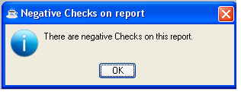
• Press OK to continue.

If the printed report contains the message, Warning, Negative Total, the checks and Check Register will show a voided check.

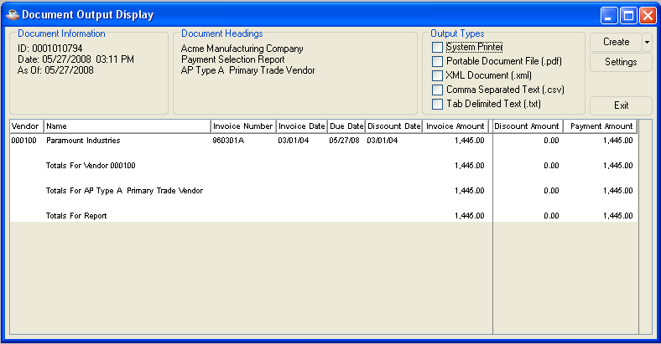

Check Printing
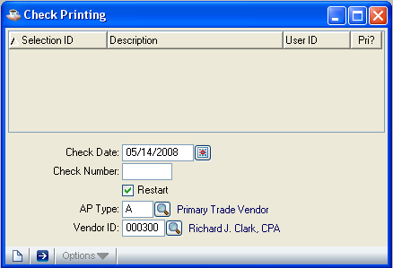
Check Printing

Function
The payment selections you made in the Payment Selection task determine the checks that are printed. You can restart the checks when you have a printer problem, and the module voids unusable checks. Check printing precedes the Check Register and update process.

■ To access this task...

Select Check Printing from the Accounts Payable Processing Menu.

About the Fields
The check printing process operates in either a standard check printing mode or in a restart mode (required when the check printing process is not successfully completed and some or all of the checks must be reprinted). The Restart field is accessed first so that you can select the mode to run. This is the only time when multiple AP types is Y. If it is N, the Check Date field is first and the rest of the fields are accessed in order on the screen.

To print the checks in accounts payable type sequence and ascertain that the right cash account is posted, you must set the Print Checks in AP Type Sequence, Multiple AP Types, and Multiple Distributions parameters to Y, and be sure that the distribution code assigned to each invoice (in the Invoice Entry task) corresponds to the correct accounts payable type. Checks will be issued for the invoices selected in the Payment Selection task, as shown on the Payment Selection Report.

In the Check Date field...
• Enter the date you want on the checks or click the Calendar button to select a date by using the calendar tool. Default date is current date.

When the General Ledger module is installed, the date entered is used when general ledger postings are made for the cash, discounts and accounts payable accounts.

NOTE: Checks can be printed by accounts payable type (for example, all vendors of a like type are printed in a group) when the parameters for both Print Checks in AP Type Sequence and Multiple AP Types are set to Y.

In the Check Number field...
• Enter the number of the first check to be printed.

CAUTION: Be sure that you enter the check number that is preprinted on the check. If the correct number is not entered, the internal record of the checks printed by the Accounts Payable module will not be correct.

In the Restart field...
- Check the Restart checkbox to reprint the checks, starting with a specific vendor. The module takes you to the AP Type field. Refer to Restarting Check Printing after these instructions.
- Uncheck the Restart checkbox to print checks that have not been interrupted.

Restarting Check Printing
When the printer jams or malfunctions, you can use the Restart Check Print option to reprint checks, beginning with a specific vendor. To restart check printing, determine the vendor number of the first check to be reprinted. Printing restarts based on the AP type/vendor combination.

In the AP Type field...
This field appears only when you enter Y in the Restart field and the Multiple AP Type parameter is set to Y.
- Enter the type code of the vendor for whom check printing is restarted.
- Click the Find button to select from a list of existing type codes.

In the Vendor Number field...
This field is accessible only when you enter Y in the Restart field.
- Enter a valid vendor number. The vendor’s name is displayed.
- Click the Find button from a list of existing vendor numbers.

The check printing restart point should begin with the vendor number following the last properly printed check.

- Click the Run Process Button to start check printing
- Click the Close Window button to return to the Accounts Payable Processing Menu

Printing

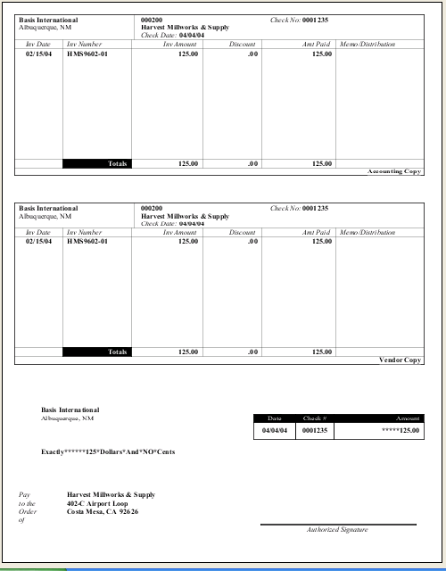

After the checks are printed, the menu appears and you should run the Check Register and update.

Reprinting
During reprinting, the checks not printed successfully are recorded as void beginning with the original check number assigned to the vendor when printing resumed. When the reprint process uses a check number that is recorded as already printed (for instance, a printer jam where the check is logged as printed, however the physical check did not print), the module lists the used and void check numbers properly.

When check printing is restarted, the vendor number indicates where the process should begin and the check number is appropriately assigned to the check. The check printing process keeps track of the numbers used regardless of the outcome of the printing process. Check numbers assigned to unsuccessfully printed checks (for example, one that is not usable) are recorded as void.

The Check Register will allow you to verify that the module has kept track of void checks correctly.

Check Register
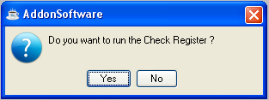
Check Register

Function
The Check Register lists all the vendor checks, including void checks, that were printed in the most recent batch of computer-printed checks. The list is in check number order. When the register is printed and verified, the update process begins. It creates the general ledger postings, posts payments to the Vendor Master file and Disbursement History file, and optionally updates the bank reconciliation files.

■ To access this task...

Select Check Register from the Accounts Payable Processing Menu.

NOTE: Print the register only after checks are printed for the selected payments.

- Click Yes to run the register,
- Click No or the Close Window button to return to the Accounts Payable Processing Menu

Printing
When multiple accounts payable types are used, the void checks are grouped at the beginning each accounts payable type section. The Check Register will appear in the Document Output Display window. Select your desired output format and click the Create button:

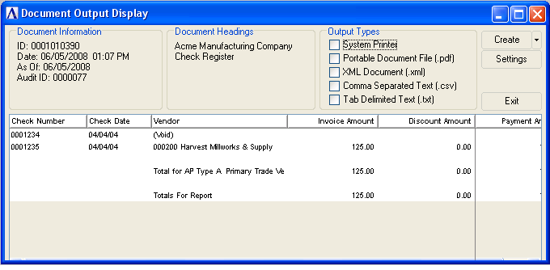

If General Ledger is installed and the GL Posting Parameter is set to Y, you’ll be presented with a second Document Output Display window. This GL recap lists general ledger postings, in account number order, created during the Check Register. If the GL Recap report detects any other errors, you’ll be presented with an error message.

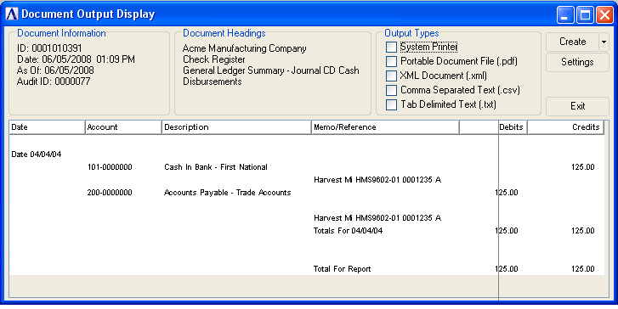

As with the register, choose your Output Type and click the Create button. After the file is created or printed, click the Close Window button to close the Document Output Display window.

When the printing is complete the module issues the prompt:

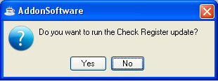

- Click Yes when the register was printed correctly and corresponds to the check information.
- Click No when the information on the check register does not correspond to the check information. You are returned to the Accounts Payable Processing Menu without updating.

Updating
The update process adjusts open invoices, disbursements history, and vendor payment history. When the General Ledger module is installed, the General Ledger Daily Detail file is also updated. When the Bank Reconciliation parameter is set to Y, check information is updated in the bank reconciliation files. When the Update process is completed without any errors, a message box will be displayed:

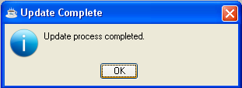

Manual Check Entry
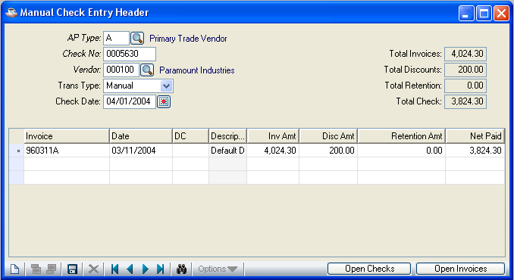
Manual Check Entry

Function
Use this task to enter manual checks, void checks, and check reversals.

■ To access this task...

Select Manual Check Entry from the Accounts Payable Processing Menu.

About the Fields
The Manual Check Entry screen is divided into two sections. The upper sections describe the check and vendor. The lower section describes invoice information. The fields you use depend on the type of transaction you are recording (manual check entry, check void, check reversal).

In the AP Type field...
This field is accessible only if you entered Y in the Multiple AP Type parameter.
- Enter a type code of the vendor for whom you are entering manual checks.
- Click the Find button to select from a list of existing type codes.

In the Check Number field...
• Enter a check number of 1 to 7 digits.
- Click the Record Query button to select existing manual check entries records.
- Click the record navigating buttons; First Record buttonto view the first record, Previous Record buttonto view the previous record, Next Record buttonto view the next record and Last Record button to view the last record.

If the check number entered is an open manual check or computer check, the following message box will appear:

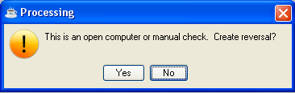

- Click Yes to make the transaction type ‘Reversal’. If the check not associated with the vendor selected above, the vendor will be changed to the vendor associated with the check.
- Click No to enter a different check number.

In the Vendor field...
- Enter a valid vendor number. The vendor’s name is displayed.
- Click the Find button to select from a list of existing vendor numbers.

NOTE: Only the AP Type, Check Number, Transaction, and Check Date fields are used when you are voiding a check.

If you enter a vendor number for which the previously entered AP type is not valid, the following message appears:

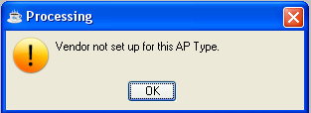

- Click OK or Close Window button to return to the vendor id field

In the Transaction Type field...
- Select Manual from the Trans Type list box to record the accounting information from a check that was manually prepared (that is, not printed by the computer).
- Select Void from the Trans Type list box to void a check. Void checks that have not been updated in the Accounts Payable module (for example, a blank check was destroyed or lost).
- Select Reversal from the Trans Type list box to reverse a check, which reverses the payment record and general ledger postings (if General Ledger installed) of a check printed by or recorded in the Accounts Payable module (for example, a check was issued to a vendor and never cashed). Invoice will remain open for the vendor.

NOTE: If the Monthly Check file was cleared by Period-End Update or by running the Purge Zero Invoices task, a check cannot be reversed with this process. Adjust the invoice in the Invoice Entry task, and when the General Ledger module is installed, make correcting journal entries to the general ledger.

In the Check Date field...
- Enter the date for the transaction or click the Calendar button to select a date by using the calendar tool
- Press Return to accept default date which is current date

When the General Ledger module is installed, this date determines the general ledger posting date for the manual check and related invoices not previously entered through the Invoice Entry task. For voided checks, enter the date the check is to be recorded as void in the Monthly Check Register.

NOTE: When the Post to Closed Periods parameter is set to N, you cannot enter a check date that falls within a closed general ledger period.

In the Invoice No field...

• Enter 1 to 10 alphanumeric characters for the invoice number.

If the invoice does not have a number, enter up to ten identifying characters such as the invoice date.

If the invoice number was not previously entered, the module issues the prompt:

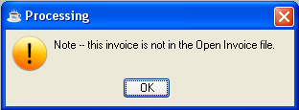

- Click OK or Close Window button to proceed with entering the required invoice information.

Since invoice numbers are not always unique, the Accounts Payable module creates a unique number by combining the 10-character invoice number with the vendor number. When you enter an invoice number, the module verifies whether the invoice number/vendor number combination already exists.

When the invoice is in the Open Invoice file, the invoice information is displayed. An invoice amount of zero (.00) indicates that the invoice was paid.

CAUTION: Check the invoice number if you think the invoice was entered through the Invoice Entry task, though the date and amounts are not displayed on the screen when you enter the invoice number. When you accidentally enter another invoice number, the invoice is posted twice. When using multiple accounts payable types, remember that the combination of accounts payable type, vendor, and invoice number are used to determine if the invoice is already in the Open Invoice file.

When an existing invoice is not found, you are advanced to the Date field.

In the Date field...
- Enter the date for the invoice.
- Click the Calendar button to select a date by using the calendar tool

In the DC field...
- Enter a valid distribution code.
- Click the Find button to select from the list of available distribution codes
When the Multiple Distributions parameter is set to Y, you must enter a valid distribution code. When the Multiple Distributions parameter is set to N, then the standard distribution code (two spaces) is assigned to the transaction.

In the Inv Amt field...
- Enter the invoice amount to be paid.
- Press Return to accept the amount displayed.

Payment cannot be made for more than the invoice amount that is displayed. You must use the Invoice Entry task to adjust the invoice to a larger amount before an increased payment amount is allowed. To specify a partial payment, enter a lesser amount here.

NOTE: Invoices can be entered either through the Invoice Entry task (in which case they may be referred to as ‘Open’) or through Manual Check Entry. Manual Invoices allow the user to quickly enter and pay an invoice, bypassing the full detailed invoice entry. However, you cannot make partial payments to a Manual Invoice. Any unpaid amount of a manual invoice will need to be entered separately through the Invoice Entry task.

Invoice Amount Example For Invoices Entered Through Invoice Entry
An invoice for $100 was entered into Invoice Entry (Inv # 1234567890). To make a partial payment of $60, less a $5 discount, enter 1234567890 in the Invoice Number field (make sure the AP type and vendor number correspond to those entered in the Invoice Entry). Enter the $60 in the Invoice Amount field and $5 in the discount field. The actual payment is a $55 manual check. The unpaid balance of $40 appears on the Aging Report after the check is updated.

Invoice Amount Example For Invoices Entered Through Manual Check Entry
To enter a partial payment of $60 on an invoice for $100 with a $5 discount through Manual Check Entry, enter the invoice in the Invoice Number field, $60 in the Invoice Amount field, $5 in the Discount field. Total payment is $55. If the outstanding $45 needs to be recorded in the system, enter an invoice for $45 through Invoice Entry.

In the Discount field...
• Enter the amount of the discount taken.

In the Net Paid field...
Display only. Shows the amount of payment for the invoice minus the discount.

In the Retention field...
This field is displayed only when the Retention parameter is set to Y.
Display only. Shows the amount of retention as entered in the Invoice Entry task.

The retention amount, when present, is subtracted from the payment amount. The retention amount cannot be included in the first payment on an invoice. On subsequent payments, the retention amount is included in the invoice amount and payment can be made.

When a manual check is used to pay an invoice not previously entered into the Accounts Payable module, you must enter the distributions. The total amount that must be distributed is shown in the Distribute field and the sum of the distribution amounts must match this total before the entry is complete.

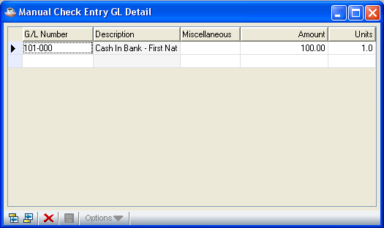
Manual Check Entry GL Detail

In the G/L Number field...
This field is accessible only if the General Ledger module is installed.
- Enter a valid general ledger account number.
- Click the Find button to select from a list of existing accounts.
- If a default account number has been assigned to the vendor, you may accept or override it.

In the Miscellaneous field...
This field appears only when the Miscellaneous Entry parameter is set to Y.
• Enter additional information about the distribution.

In the Amount field...
• Enter the amount to be distributed.

When the General Ledger module is installed, normally only the debit side of the entry is entered, and the credit side is supplied automatically during the Manual Check Register update from the distribution code associated with the check. A positive amount results in a debit posting to the account during the Manual Check Register update process. A negative amount results in a credit posting.

In some cases, it is necessary to post to the alternate accounts payable account supplied by the distribution code. Do this by debiting the pre-assigned accounts payable account (entering a positive number) and crediting the desired accounts payable account (entering a negative number).

In the Units field...
This field is accessible only when the General Ledger module is installed and the Use Units parameter is set to Y in the General Ledger parameters.
• Enter the number of units associated with the distribution.

Units are used to track non-dollar quantities in the General Ledger module for reporting purposes. Units need not balance against any other number.

While in the detail grid, use the Enter key to toggle between navigation mode and edit mode in a given cell. In navigation mode, the cell has a dotted outline. In edit mode, the contents of the cell are selected.

While in edit mode
• Use the Enter key to accept the edits and remain in the cell, toggling to navigation mode
- Use the Tab key to accept the edits and move to the next cell

While in navigation mode
- Use the Enter key to highlight the contents of the cell and perform edits (i.e., toggles to edit mode)
- Use the arrow or tab keys to move to different cells

After completing the distribution details;

- Click the Save button to save the distribution details.
- Click the Delete button to delete the current line of Distribution record.
- Click the Close Window button to return to the Manual Check Entry screen after changing, saving or deleting the distribution records.

The module compares the value of the Distribute field to the total of the distribution lines. When the invoice amount is fully distributed, the entered distribution information is accepted. The task returns to the Invoice No field where you can enter information for the next invoice to be paid with the check. When the two amounts do not balance, the module issues the prompt:

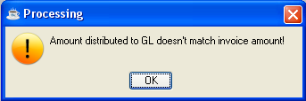

- Click OK to adjust the amounts on the distribution lines to balance to the invoice amount.

After finishing the manual check entries;

- Click the Save button to save the manual check entry.
- Click the New button to begin a new manual check entry
- Click the Delete button to delete the current manual check entry.
- Click the Close Window button to return to the Accounts Payable Processing Menu.

Manual Check Register
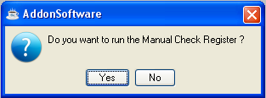
Manual Check Register

Function
The Manual Check Register is a list of the checks entered through Manual Check Entry task, including void and reversed checks. The invoices, amounts and check totals are shown for each manual check.

■ To access this task...

Select Manual Check Register from the Accounts Payable Processing Menu.

- Click Yes to run the register
- Click No or the Close Window button to return to the Accounts Payable Processing Menu

Printing
The Manual Check Register will appear in the Document Output Display window. Select your desired output format and click the Create button:

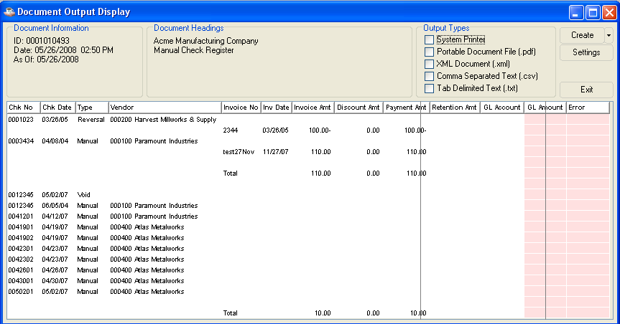

Any data shaded with pink in the Document Output window is at risk of truncation when the document is printed or saved in pdf format. Click and drag to adjust column sizes until no pink shading remains. If the report is too large to adjust in this manner, save it in one of the disk file formats (xml, csv, txt) in order to prevent data loss.

When the printing is complete, the module issues the prompt:

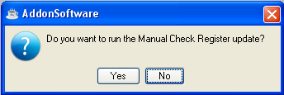

- Click Yes when the register is printed correctly and balances to the totals for the checks.
- Click No or Close Window button when the manual check information is incorrect. Return to the Manual Check Entry task to make corrections. When the register is correct, proceed with the update.

Updating
The manual checks are updated to the Open Invoice file and Monthly Check file. The disbursement history is updated for each paid vendor. Void checks are recorded in the Monthly Check file. When the General Ledger module is installed, the General Ledger Daily Detail file is posted as required for manual check and check reversals. .

NOTE: For each invoice not initially entered through the Invoice Entry task, a transaction is automatically created and added to the Open Invoice file during the Manual Check Register Update process. This transaction, which can be viewed in the Open Invoice Inquiry option of the Vendor Maintenance, has an identification of MI (Manual Invoice). The amount of this type of transaction corresponds to the amount of the manual check applied to the invoice. Any “unpaid” amount of for the invoice is not recorded in the system unless it was entered separately through the Invoice Entry task. This type of transaction exists to enable audit tracking of invoices paid by manual checks.

AP Aging Report
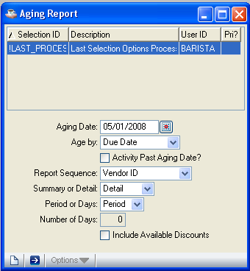
Aging Report

Function
The Aging Report is a tool used for making payment decisions. The report groups all or selected outstanding invoices into aging periods that you determine before printing. The selected periods can be the fiscal calendar periods or a number of days in length, usually 30.

■ To access this task...

Select Aging Report from the Accounts Payable Processing Menu.

About the Fields

In the Aging Date field...
• Enter the beginning date for the report or click the Calendar button to select a date by using the calendar tool.
- Click the Close Window button to return to the Accounts Payable Processing Menu.

If aging by periods, the date entered is used to determine which period is “current”. Invoices dated after that period will be shown as “future”. Invoices with dates within the date range of the “current” period fall into the first aging column after the “future” column. Invoices with dates prior to the current period fall into subsequent aging columns. It is similar for aging “by # of days” except that the date entered is used as the “through “ dates for the first aging columns (the current column). Invoices dated after this date are considered future. When aging by number of days, enter the day you want to use as a reference for determining the aging periods. Each invoice is aged based on its invoice date, accounting date or due date (Refer to Aging Option field).

In the Age By field...
- Select Invoice Date from the Drop down box to age each invoice based on the invoice date.
- Select Due Date from the Drop down box to age each invoice based on the invoice due date.
- Select Accounting Date from the Drop down box to age each invoice based on the accounting date.

The aging option determines the date used to calculate the invoice age. The task compares the selected date for each invoice to the aging date and determines the time period it falls into.

In the Include Activity Past Aging Date field...
- Check the Activity Past Aging Date to include all invoices and payments regardless of their dates.
- Uncheck the Activity Past Aging Date to include only activity that occurred on or before the aging date.

In the Report Sequence field...
- Select Alternate Sequence from the drop down box to sort the report by alternate sequence (alphabetical).
- Select Vendor ID from the drop down box to sort by vendor number.

In the Summary Or Detail field...
- Select Summary from the drop down box to print only summary totals for each vendor.
- Select Detail from the drop down box to print each vendor invoice on a detail line.

In the Period Or Days field...
- Select Period from the drop down box to base the aging time periods on the fiscal calendar.
- Select Days from the drop down box to define time periods as a number of days.

In the Number Of Days field...
This field is bypassed when you select ‘Periods’ In the Period Or Days field.
• Enter the number of days for the time period.

Number of Days Example
Enter 7 to group invoices into 7-day periods.

In the Include Available Discounts field...
- Check the Include Available Discounts to include available discounts in the report
- Uncheck the Include Available Discounts to exclude available discounts in the report
- Click the Run Process Button or press F5 to print the aging report
- Press the New /Clear form button to clear the form after saving or not saving the current entry. If the current entry is saved, the aging report based on the current entry will be displayed.
- Click the Close Window button to return to the Accounts Payable Processing Menu.

Printing

When the Multiple AP Types parameter is set to Y, the report sorts and subtotals by accounts payable types. The Aging Report will appear in the Document Output Display window. Select your desired output format and click the Create button:

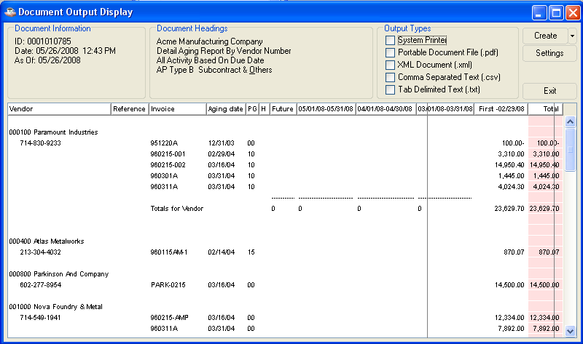

Any data shaded with pink in the Document Output window is at risk of truncation when the document is printed or saved in pdf format. Click and drag to adjust column sizes until no pink shading remains. If the report is too large to adjust in this manner, save it in one of the disk file formats (xml, csv, txt) in order to prevent data loss.

Cash Requirements Report
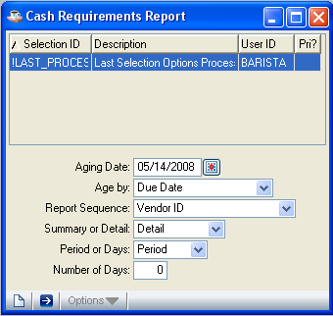
Cash Requirements Report

Function
This report is a cash requirements analysis tool that groups open invoices into user-defined time periods. Four time periods, defined either by the fiscal calendar or by number of days specified, are provided on the report. Both the Cash Requirements Report and the Aging Report provide detailed information for making payment selections.

■ To access this task...

Select Cash Requirements Report from the Accounts Payable Processing Menu.

About the Fields

In the Aging Date field...
• Enter the beginning date for the report or click the Calendar button to select a date by using the calendar tool.
- Click the Close Window button to return to the Accounts Payable Processing Menu.

Enter a date to use as a reference date for determining the projection periods. Each invoice is aged based on its invoice date, accounting date or due date (Refer to Aging Option field).

In the Age By field...
- Select Invoice Date from the Drop down box to age each invoice based on the invoice date.
- Select Due Date from the Drop down box to age each invoice based on the invoice due date.
- Select Accounting Date from the Drop down box to age each invoice based on the accounting date.

The aging option determines the date used to calculate the invoice age. The task compares the selected date for each invoice to the aging date and determines the time period it falls into.

In the Report Sequence field...
• Select Alternate Sequence from the drop down box to sort the report by alternate sequence (alphabetical).
- Select Vendor ID from the drop down box to sort by vendor number.

In the Summary Or Detail field...
• Select Summary from the drop down box to print only summary totals for each vendor.
- Select Detail from the drop down box to print each vendor invoice on a detail line.

In the Period Or Days field...
• Select Period from the drop down box to base the aging time periods on the fiscal calendar.
- Select Days from the drop down box to define time periods as a number of days.

In the Number Of Days field...
This field is bypassed when you select Period in the Period Or Days field.
• Enter the number of days for the time periods.

Number of Days Example
Enter 7 to group invoices into 7-day periods.

- Click the Run Process Button or press F5 to print the cash requirement report
- Press the New button to clear the form after saving or not saving the current entry. If the current entry is saved, the cash requirement report based on the current entry will be displayed.
- Click the Close Window button to return to the Accounts Payable Processing Menu.

Printing
When the Multiple AP Types parameter is set to Y, the report sorts and subtotals by accounts payable types. The Cash Requirement Report will appear in the Document Output Display window. Select your desired output format and click the Create button:

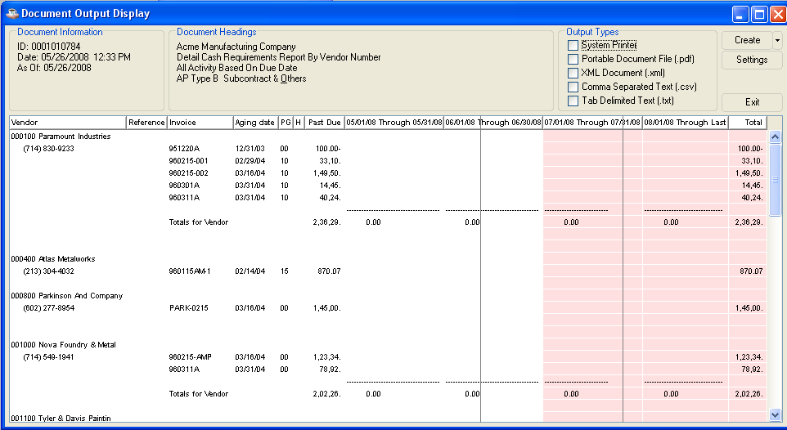

Any data shaded with pink in the Document Output window is at risk of truncation when the document is printed or saved in pdf format. Click and drag to adjust column sizes until no pink shading remains. If the report is too large to adjust in this manner, save it in one of the disk file formats (xml, csv, txt) before printing in order to prevent data loss.

Accounts Payable Reports
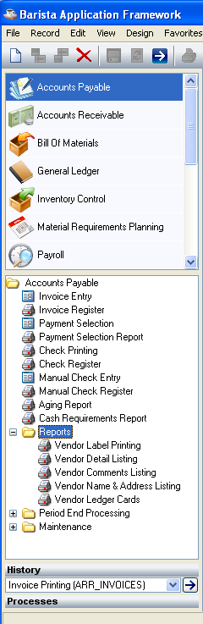
Accounts Payable Reports Menu

Function
The reports and listings available to the Accounts Payable module have all been gathered together in this task to make it easier for you to access them. Use this task when you want to print labels or ledger cards, etc., or to print vendor information of several types.

- To access the Accounts Payable Reports…

Select the Reports after accessing Accounts Payable.

About the Accounts Payable Reports Menu
To print any report or listing identified on this menu, select that report from the Reports menu.

Vendor Label Printing
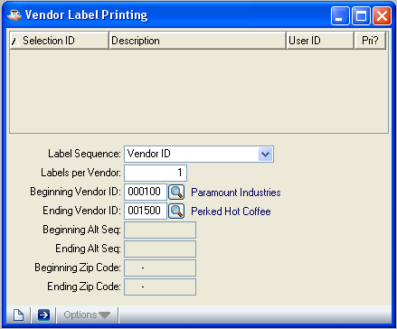
Vendor Label Printing

Function
This task prints vendor labels in vendor number, alphabetic (alternate), or zip code sequence. Labels for all vendors or a range of vendors can be printed. The positioning of the label printing (how many labels across and spacing between labels) is specified in the Parameter Maintenance task.

n To access this task...

Select Vendor Label Printing from the Accounts Payable Reports Menu.

About the Fields

In the Label Sequence field...
• Select Alternate Sequence from the Label Sequence drop down box to print by alternate code sequence.
- Select Vendor ID from the Label Sequence drop down box to print by vendor number sequence. Vendor ID is the default selection.
- Select Zip Code from the Label Sequence drop down box to print by zip code sequence.

In the Labels Per Vendor field...
• Enter the number of labels to print for each vendor.

In the Beginning Vendor ID field...
This field is accessible only when you select Vendor ID from Label Sequence drop down box.
- Enter a beginning vendor id or click the Find button to select from a list of existing vendor numbers.
- To start with the first vendor on file, leave the Vendor ID blank.

In the Ending Vendor ID field...
This field is accessible only when you select Vendor ID from Label Sequence drop down box.
- Enter an ending vendor id or click the Find button to select from a list of existing vendor numbers.
Leave the Vendor ID blank to select the last vendor on file.

In the Beginning Alt Seq field...
This field is accessible only when you select Alternate Sequence from Label Sequence drop down box.
• Enter a beginning Alternate Sequence
- Leave the field blank to select the first alternate sequence on file.

In the Ending Alt Seq field...
This field is accessible only when you select Alternate Squence from Label Sequence drop down box.
• Enter an ending Alternate Sequence
- Leave the field blank to select the last alternate sequence on file.

In the Beginning Zip Code field...
This field is accessible only when you select Zip Code from Label Sequence drop down box.
- Enter a beginning Zip Code
- Leave the field blank to select the first zip code on file.
In the Ending Zip Code field...
This field is accessible only when you select Zip Code from Label Sequence drop down box.
• Enter an ending Zip Code
- Leave the field blank to select the last zip code on file.

Click the Run Process Button to print the Vendor Label. The module issues a message box:

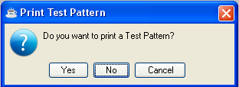

• Click Yes when you want to print test pattern.
- Click No to begin printing without a test pattern.
Click Cancel or Close Window button return to the Accounts Payable Reports Menu without printing

Printing
The Vendor Labels will appear in the Print Preview window. Click the Print button to take a print out of the labels

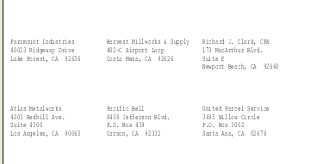

Vendor Detail Listing
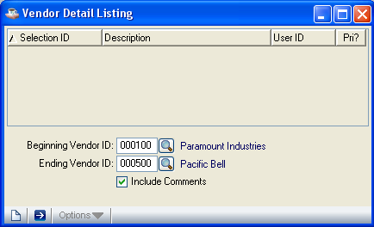
Vendor Detail Listing

Function
This task prints information for a range of vendors. This same information is printed by the Hard Copy Printing option of the Vendor Maintenance task. Vendor detail information is printed in vendor number sequence.

■ To access this menu...

Select Vendor Detail Listing from Accounts Payable Reports Menu.

About the Fields

In the Beginning Vendor field...
- Enter the number of the first vendor to appear on the report.
- Leave the field blank to begin the report with the first vendor on file.
- Click the Find button to select from a list of existing vendor numbers
- Click the Close Window button to return to the Accounts Payable Reports Menu.

In the Ending Vendor field...
- Enter the number of the last vendor to appear on the report.
- Leave the field blank to end the report with the last vendor on file.
- Click the Find button to select from a list of existing vendor numbers.
- Click the Close Window button to return to the Accounts Payable Reports Menu.

In the Include Comments? field...
• Check the Include Comments box to include vendor comments on the printed report.
- Uncheck the Include Comments box to exclude vendor comments.

• Click the Run Process Button to print the Vendor Detail Listing
- Click the Close Window Button to return to the Accounts Payable Reports Menu without printing.

Printing

The Vendor Detail Listing will appear in the Document Output Display window. Select your desired output format and click the Create button:

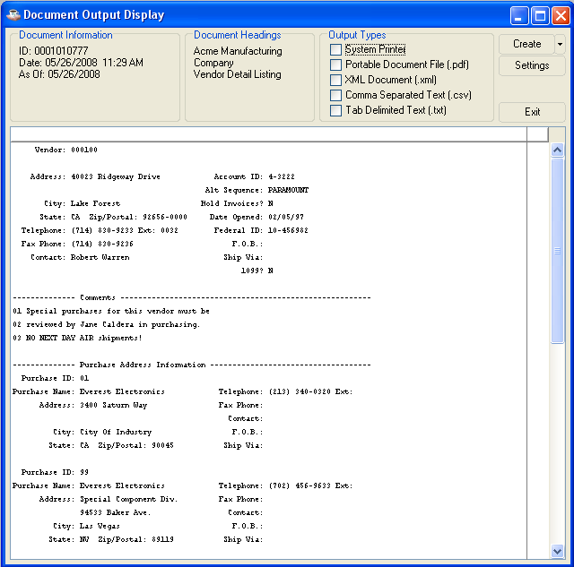

Vendor Comments Listing
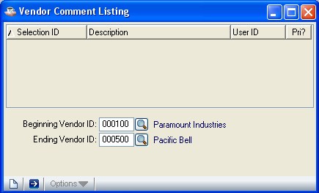
Vendor Comments Listing

Function
The Vendor Comments Listing is a list of vendor numbers, names, contact information and any special comments previously noted pertaining to a particular vendor.

n To access this task...

Select Vendor Comments Listing from the Accounts Payable Reports Menu.

About the Fields

In the Beginning Vendor field…
- Enter the number of the first vendor to appear on the report.
- Leave the field blank to begin with the first vendor number listed.
- Click the Find button to select from a list of existing vendor numbers.

In the Ending Vendor field…
- Enter the number of the last vendor to appear on the report.
- Leave the field blank to end with the last vendor number on file.
- Click the Find button to select from a list of existing vendor numbers.

• Click the Run Process Button to print the Vendor Comments Listing
- Click the Close Window Button to return to the Accounts Payable Reports Menu without printing.
.

Printing
The Vendor Comments Listing will appear in the Document Output Display window. Select your desired output format and click the Create button:

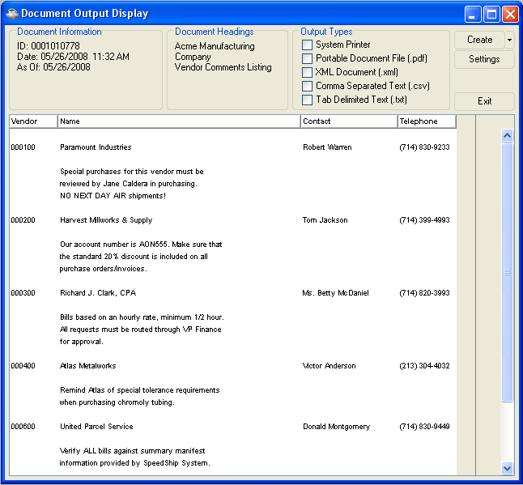

Vendor Name and Address Listing
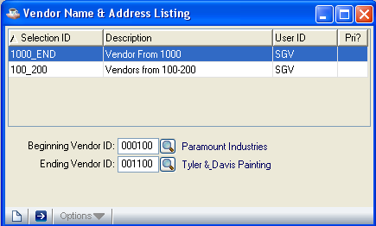
Vendor Name and Address Listing

Function
This task prints vendor number, name and address, contact, telephone and fax information.

n To access this task...

Select Vendor Name and Address Listing from the Accounts Payable Reports Menu.

About the Fields

In the Beginning Vendor field...
- Enter a vendor number.
- Leave the field blank to start at the first vendor listed on file.
- Click the Find button to select from a list of existing vendors.

In the Ending Vendor field...
- Enter a vendor number.
- Leave the field blank for the last vendor number listed on file.
- Click the Find button to select from a list of existing vendors.

• Click the Run Process Button or press F5 to print the Vendor Name and Address Listing
- Click the Close Window button to return to the Accounts Payable Reports Menu without printing

Printing
The Vendor Name and Address Listing will appear in the Document Output Display window. Select your desired output format and click the Create button:

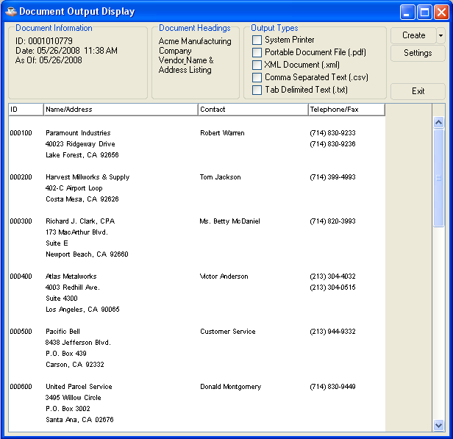

Vendor Ledger Cards
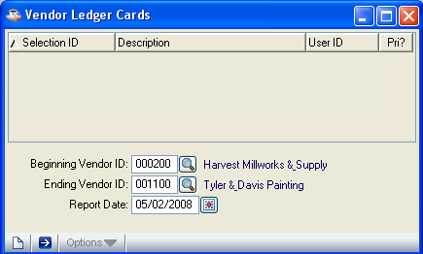
Vendor Ledger Cards

Function
You can print Vendor Ledger Cards for a range of vendors. Each card lists the outstanding invoices, up through a selected date. The invoice number, date, amount and date due are shown.

n To access this task...

Select Vendor Ledger Cards from the Accounts Payable Reports Menu.

About the Fields

In the Beginning Vendor field...
• Enter the number of the first vendor requiring a printed ledger card.
- Leave the field blank to begin with the first vendor on file.
- Click the Find button to select from a list of existing vendors.

In the Ending Vendor field...
- Enter the number of the last vendor requiring a printed ledger card.
- Leave the field blank to end with the last vendor on file.
- Click the Find button to select from a list of existing vendors.

In the Report Date field...
- Enter the date through which all transactions should be included.
- Click the Calendar button to select a date by using the calendar tool

• Click the Run Process Button to print the Vendor Ledger Cards
- Click the Close Window button to return to the Accounts Payable Reports Menu without printing

Printing
The Vendor Ledger Cards will appear in the Document Output Display window. Select your desired output format and click the Create button:

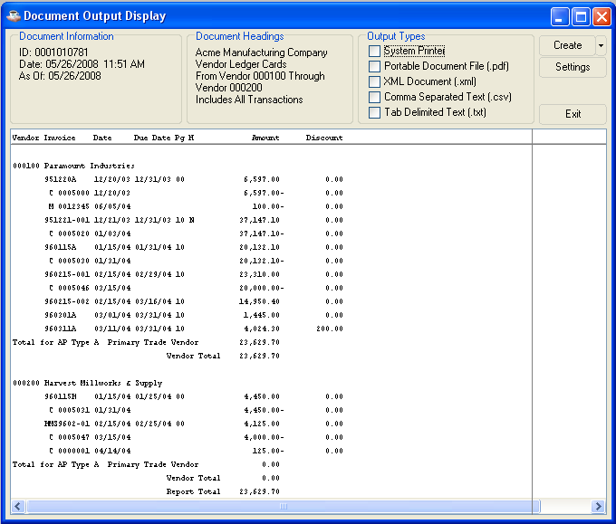

Period End Processing Menu
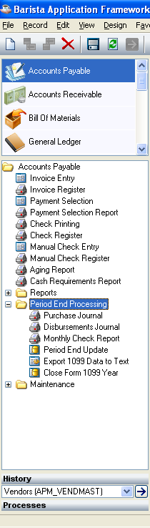

Period End Processing Menu

Function
This menu allows access to tasks that print the Purchase Journal, Disbursements Journal, Monthly Check Report and 1099 Forms. The Period End Update is also accessed from this menu.

■ To access this task...

Select Period End Processing after accessing Accounts Payable.

About the Period End Processing Tasks
To access any task on this menu, select the task from the menu

The tasks on this menu enable you to list invoices entered and updated in the module, show the disbursements of checks printed, list all checks processed during a selected period, print 1099 Forms, remove zero balance invoices from your open invoice file and update all transactions fully reconciled with the general ledger.

Purchase Journal
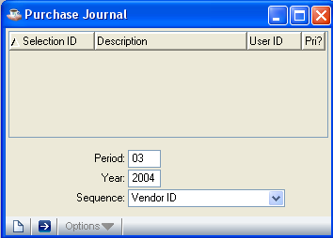
Purchase Journal

Function
Use the Purchase Journal to list invoices entered and updated in the Accounts Payable module for a selected accounting period. The report can print in vendor number, distribution account or alternate sequence. When the General Ledger module is installed, you have an additional option to print by general ledger distribution.

■ To access this task...

Select Purchase Journal from the Period End Processing Menu.

NOTE: Because the Open Invoice file is used to produce the Purchase Journal, it is very important that the Retain Zero Invoices parameter be set to Y when you want to print the Purchase Journal for prior periods.

About the Fields

In the Period field...
• Enter the desired accounting period for the report. Current period will be the default value

In the Year field...
• Enter the desired accounting year for the report. Current year will be the default value

NOTE: Because the Purchase Journal does not update information, you can select any accounting period in the fiscal year regardless of whether records exist for the selected period. However, the Purchase Journal only prints the information for prior periods if the information has not been cleared (Refer to Period End Update).

In the Sequence field...
- Select Alternate Sequence from the Sequence drop down box to print the journal by vendor alternate sequence.
- Select Distribution Account from the Sequence drop down box to print the report by distribution account sequence (only if G/L is installed).
- Select Vendor ID from the Sequence drop down box to print the report by vendor number sequence. Vendor ID will be the default selection.

The contents of the report are the same regardless of the sequence selected.

NOTE: Printing the report in distribution sequence (D) causes the task to first sort the records in the file. The amount of time the sort consumes depends on the number of records in the file.

- Click Run Process Button to print the Purchase Journal
- Click the Close Window button to return to the Period End Processing Menu without printing

Printing
When the Multiple AP Types parameter is set to Y, the report is grouped and subtotaled by accounts payable type. The Purchase Journal will appear in the Document Output Display window. Select your desired output format and click the Create button:
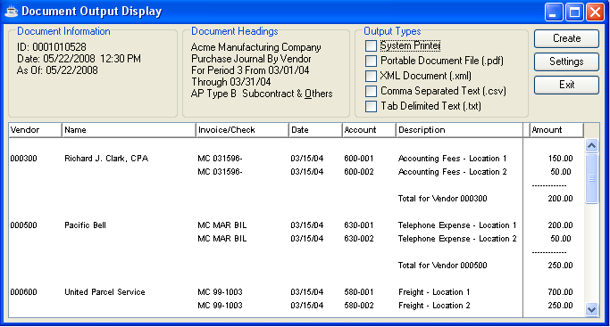

After the file is created or printed, click the Close Window button to close the Document Output Display window.

If General Ledger is installed and the GL Posting Parameter is set to Y, you’ll be presented with a second Document Output Display window. This GL recap lists general ledger postings, in account number order, created during the Purchase Journal. If the GL Recap report detects any other errors, you’ll be presented with an error message.

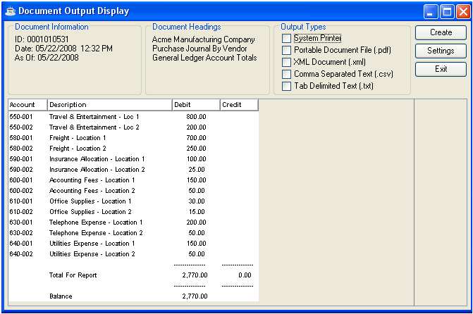

Choose your Output Type and click the Create button. After the file is created or printed, click the Close Window Button to close the Document Output Display window.

Disbursements Journal
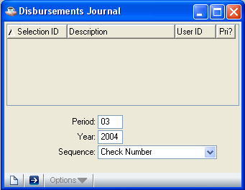
Disbursements Journal

Function
Use the Disbursements Journal to list the disbursements for the checks printed during the selected accounting period. You can print the report in check number sequence, alternate sequence, or vendor id sequence.

■ To access this task...

Select Disbursements Journal from the Period End Processing Menu.

About the Fields

In the Period field...
• Enter the desired accounting period for the report. Current period will be the default value

In the Year field...
• Enter the desired accounting year for the report. Current year will be the default value

NOTE: Because the Disbursements Journal does not update information, you can select any accounting period in the fiscal year regardless of whether or not records exist for the selected period. However, the Disbursements Journal only prints the information for prior periods if the information has not been cleared (Refer to Period End Update).

In the Report Sequence field...
- Select Alternate Sequence from the Sequence drop down box to print the report by alternate sequence.
- Select Check Number from the Sequence drop down box to print the report by check number sequence.
- Select Vendor ID from the Sequence drop down box to print the report by vendor number sequence. Vendor ID will be the default selection

The contents of the report are the same regardless of the sequence selected.

NOTE: Printing the report in vendor number sequence (V) causes the task to first sort the records In the file. The amount of time the sort consumes depends on the number of records in the file.

- Click Run Process Button to print the Disbursement Journal
- Click the Close Window button to return to the Period End Processing Menu without printing

Printing
When the Multiple AP Types parameter is set to Y, the report is grouped and subtotaled by accounts payable type. The Purchase Journal will appear in the Document Output Display window. Select your desired output format and click the Create button:

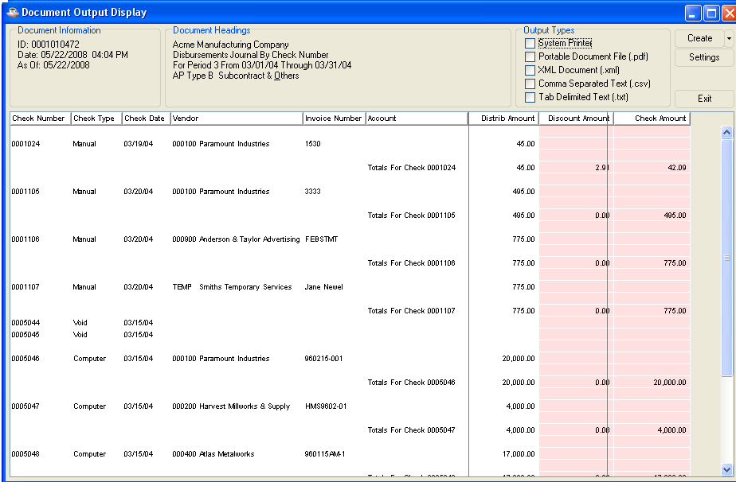
Any data shaded with pink in the Document Output window is at risk of truncation when the document is printed or saved in pdf format. Click and drag to adjust column sizes until no pink shading remains. If the report is too large to adjust in this manner, save it in one of the disk file formats (xml, cxv, txt) in order to prevent data loss.

Choose your Output Type and click the Create button. After the file is created or printed, click the Close Window button to close the Document Output Display window

If General Ledger is installed and the GL Posting Parameter is set to Y, you’ll be presented with a second Document Output Display window. This GL recap lists general ledger postings, in account number order, created during the Purchase Journal. If the GL Recap report detects any other errors, you’ll be presented with an error message.

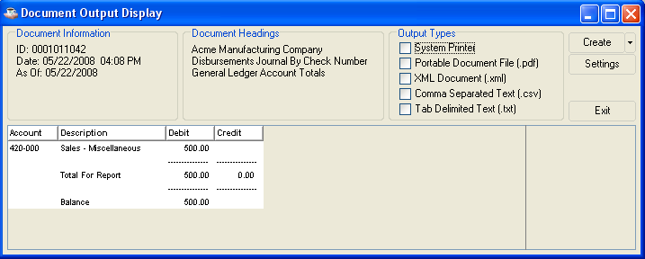

Choose your Output Type and click the Create button. After the file is created or printed, click the Close Window Button to close the Document Output Display window.

Monthly Check Report
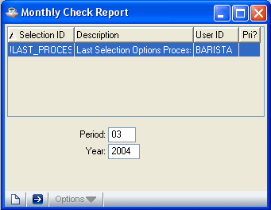
Monthly Check Report

Function
Use the Monthly Check Report to list all vendor checks, manual checks, check reversals and void checks processed during the selected accounting period. It is very important that this report be printed before running the Accounts Payable Period End Update since it purges the monthly check information contained on the report.

■ To access this task...

Select Monthly Check Report from the Period End Processing Menu.

About the Fields

In the For Period field...
• Enter the desired accounting period for the report. Current period will be the default value

In the Year field...
• Enter the desired accounting year for the report. Current year will be the default value

NOTE: Because the Monthly Check Report does not update information, you can select any accounting period in the fiscal year regardless of whether or not records exist for the selected period.

- Press the Run Process Button to print the Disbursement Journal
- Click the Close Window button to return to the Period End Processing Menu without printing

Printing
When the Multiple AP Types parameter is set to Y, the report is grouped and subtotaled by accounts payable type.

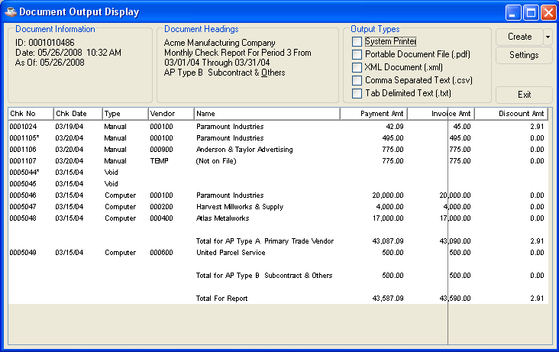

Period End Update

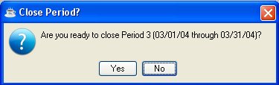
Period End Update

Function
You should use the Period End Update task only after all transactions for an accounts payable period are entered and verified. Refer to the Flow of Processing section for a detailed explanation of what is accomplished by this process.

■ To access this task...

Select Period End Update from the Period End Processing Menu.

NOTE: The Purchase Journal, Disbursement Journal, and Monthly Check Report should be printed before closing the period as the files used by these reports are affected by the period end process.

When the update process completes a message will be displayed:

AP Form 1099 Data Export
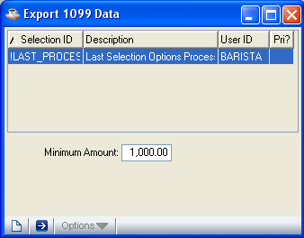
AP Form 1099 Data Export

Function
Use this task to create a file of information for all vendors flagged for 1099 in the Vendor Maintenance task. The information is taken from the Calendar Year disbursements fields for the vendor (refer to the Purchase History Inquiry option of the Vendor Maintenance task) and printed on standard 1099 Forms available from any forms supplier. No data is updated as a result of the 1099 printing process. The data file created by this process is then uploaded to a third party 1099 printing program.

■ To access this task...

Select Export 1099 Data to Text from the Period End Processing Menu.

NOTE: It is recommended that a test printing of the 1099 exported data be made on plain paper in November or early December. In addition, be sure that the data export is created before the Period End Update for December, because the Period End Update clears the calendar year-to-date disbursement figures for each vendor.

About the Fields

In the Minimum Amount field...
• Enter the minimum amount a vendor can be paid in a calendar year before being issued a 1099 form.

This minimum amount is set by the Internal Revenue Service.

NOTE: The 1099 data is not exported unless the vendor’s 1099 flag is set to Y in the Vendor Maintenance task.

The module issues a confirmation box for overwriting existing file:

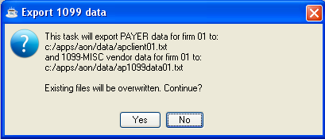

- Press Yes when you are ready to export data.
- Press No if you do not want to export data.

Close Form 1099 Year

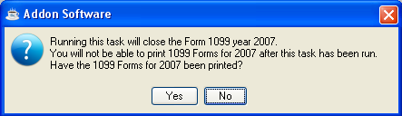

Function
Use this task to close all 1099 Forms for all vendors flagged accordingly in the Vendor Maintenance task. You should print the 1099 Forms before running this option. When all the forms are completed the module will issue the following message.

Accounts Payable Maintenance
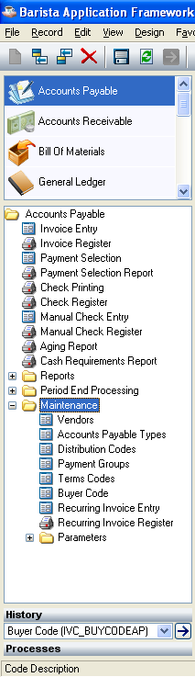
Accounts Payable Maintenance Menu

Function
Use the Accounts Payable Maintenance tasks to perform various maintenance functions such as setting up vendor files, code files, and system parameters.

n To access this menu...

Select the Maintenance button after accessing Accounts Payable.

About the Accounts Payable Maintenance Tasks

Use the tasks on this menu to set and maintain information about your vendors, companies, and accounts payable system. Vendor information comprises the vendor’s name and address, federal ID number, purchase history, receipt history, and so forth. Company information comprises the name and address of each company using the Accounts Payable module.

Vendor Maintenance
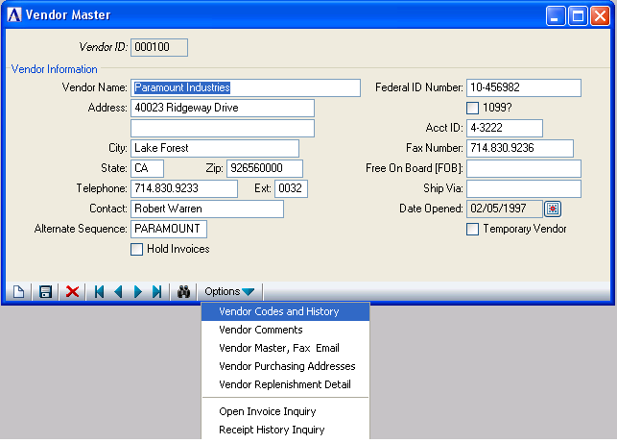
Vendor Maintenance

Function
Use this task to enter new vendor information, maintain existing vendors, inquire about vendor status and delete inactive vendors. The vendor information you set up with this task is accessed through an option menu that displays when the Options button in the Vendor Master window is clicked.

n To access this task...

Select Vendor Maintenance from the Accounts Payable Maintenance Menu.

About the Fields
This screen contains information about the vendor such as the address and phone number. When you select an existing vendor, the vendor information is displayed. More details about a vendor can be added, changed or viewed using the menu displayed when clicking the Options button.

In the Vendor ID field...
- Enter a vendor number.
- Click the Record Query button to select a vendor id from a list of existing vendor records.
- Click the record navigating buttons; First Record buttonto view the first record, Previous Record buttonto view the previous record, Next Record buttonto view the next record and Last Record button to view the last vendor record.
- Click the Close Window button to return to the Accounts Payable Maintenance Menu.

When you enter a valid vendor, the address information associated with the vendor displays. To add or change vendor records, select options from Options menu.

In the Name field...
• Enter the name of the vendor up to 30 characters.

In the Address field...
- Enter 1 to 2 lines of address information up to 24 characters each.
- Press Tab to leave this field blank.

In the City field...
• Enter the city of the vendor up to 22 characters.
- Press Tab to leave this field blank.

In the State field...
• Enter 2 letter sate code.
- Press Tab to leave this field blank.

In the Zip/Postal field...
- Enter the zip/postal code.
- Press Tab to leave this field blank.

If zip code is 9-digits, it displays with separating dashes (Example: #####-####).

In the Telephone field...
- Enter the telephone number with area code of the vendor.
- Press Tab to leave this field blank.

The phone number is displayed with punctuation for the area code and prefix.

In the Ext field...
- Enter an extension for the telephone of 1 to 4 digits.
- Press Tab to leave this field blank.

In the Contact field...
- Enter the name of the contact within the vendor’s business of up to 20 characters.
- Press Tab to leave this field blank.

In the Alt Sequence field...
- Enter an alphabetic code of 1 to 10 characters for the vendor.
- Press Tab to accept the first 10 characters of the Vendor Name as default Alt Sequence

This code is used by the Lookup function.

In the Hold Invoices field...
- Check the box Hold Invoices to hold future invoices from the vendor.
- Uncheck the box Hold Invoices to allow future invoices to be paid.

In the Federal ID Number field...
- Enter the vendor’s federal ID number of up to 15 characters.
- Press Tab to leave this field blank.

In the 1099 field...
- Check the box 1099 if 1099 Forms are printed for the vendor.
- Uncheck the box 1099 if 1099 Forms are not printed for the vendor.

In the Acct ID field...
- Enter any account number assigned by the vendor up to 10 characters.
- Press Tab to leave this field blank.

In the Fax Number field...
- Enter the telephone number with area code of the vendor’s fax machine.
- Press Tab to leave this field blank.

In the FOB field...
- Enter up to 15 characters to identify the freight charge description.
- Press Tab to leave this field blank.

In the Ship-Via field...
- Enter the standard shipping method for this vendor, up to 15 characters in length.
- Press Tab to leave this field blank.

In the Date Opened field...
- Enter the date this account was opened.
- Press Tab to accept the defaulted date.

In the Temporary Vendor field...
- Check this box if this is a Temporary Vendor.

When you finish making entries to the fields,

- Click the Save button to save the record. The form is cleared in preparation for a new entry.
- Click the New button to begin a new vendor record
- Click the Delete button to delete the record.
- Click the Close Window button to return to the Accounts Payable Maintenance Menu.

CAUTION: Until after the end of the calendar year, be sure that you do not delete vendors for whom a 1099 form should be printed.

About the Vendor Maintenance Options
Use the Vendor Maintenance option menu to enter varied information about a vendor without ever leaving the main task. Once you have selected a vendor record, you can view, change, add or delete vendor information by selecting available options from the menu.

Selecting an option allows you to add or change the data associated with the option. The Vendor Master information window will always be there. Prompts requiring your attention and pertaining to the selected option’s fields appear as another window.

Vendor Codes and History
Use this option to inquire about and change vendor detail information, accounts payable types, distribution codes, payment groups, terms codes. This window also displays the Purchase History of the vendor. When the General Ledger module is installed, you can also access default general ledger expense accounts. For more information about each of these codes, refer to Code and Vendor Information in the Installation section. This option is automatically accessed during the setup of a new vendor or you can use it at any time to change information for established vendors.

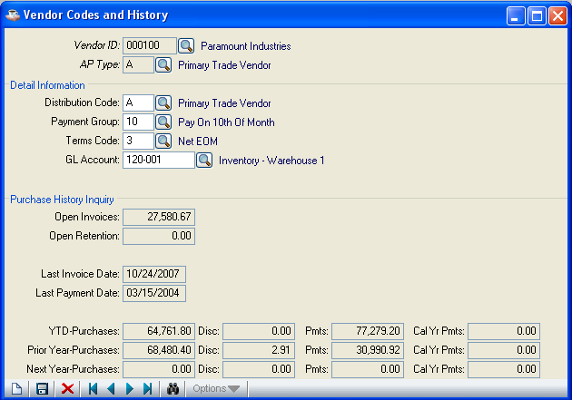

In the AP Type field...
This field appears when the Multiple AP Types parameter is set to Y.
- Enter a valid accounts payable type code.
- Click the Find button to select from a list of existing to select from a list of existing type codes.

The accounts payable types assist in managing accounts payable information. When multiple accounts payable types are used, a vendor may have one or more type.

If an existing AP type for this vendor is selected, the detail information and purchase history for that AP type and vendor is displayed.

About the Fields in Detail Information

In the Dist Code field...
- Enter a valid distribution code.
- Click the Find button to select from a list of existing distribution codes.

Distribution codes are defined in the Distribution Code Maintenance task. When the General Ledger module is installed, the general ledger account for accounts payable, cash, discounts and retention payable are assigned to each Distribution Code.

NOTE: Assigning a distribution code to the vendor provides a default distribution for invoices entered for the vendor.

In the Payment Group field...
- Enter a valid payment group code.
- Click the Find button to select from a list of existing payment group codes.

The payment group code places the vendor in a group that you can select for automatic payment. The payment group specified is assigned to new invoices that are entered.

In the Terms Code field...
- Enter a valid terms code to specify the vendor’s default payment terms.
- Click the Find button to select from a list of existing terms codes.

The terms code is assigned to new invoices that are entered.

In the GL Account No field...
This field appears only when the General Ledger module is installed.
- Enter a valid general ledger account number.
- Click the Find button to select from a list of existing general ledger account numbers.

Enter the account number that is the “normal” expense account for purchases from the vendor. Although this number appears as a default expense account for the vendor during the Invoice Entry and Manual Check Entry tasks, the account can be changed during entry.

When you finish making entries to the fields,
- Click the Save button to save the record. The form is cleared in preparation for a new entry.
- Click the New button to begin a new record
- Click the Delete button to delete the record.
- Click the Close Window button to return to the Vendor Master window

NOTE: You cannot delete an Accounts Payable type definition for a vendor when there is current activity for that vendor/distribution combination.

About the Fields in Purchase History Inquiry
When multiple accounts payable types are used, the purchase history is displayed for each AP type assigned to the vendor.

In the Open Invoices field...
Display only. Shows the total balance owed to the vendor (for a particular accounts payable type if the Multiple AP Type is Y). To view the detail information that supports this figure, use the Open Invoice Inquiry option.

In the Open Retention field...
Display only and appears only if Retention Account is Y . When the Retention Account parameter is set to Y, the total retention payable to the vendor is displayed.

In the Last Invoice Date field...
Display only. Shows the date of the most recent invoice received from the vendor.

In the Last Payment Date field...
Display only. Shows the date of the most recent check printed for the vendor.

In the YTD-Purchases field...
Display only. Shows the current fiscal year-to-date amounts for purchases, discounts, payments and calendar year-to-date payment amounts.

The calendar year-to-date payment amount covers the period from January 1st through December 31st and is used for the 1099 form and cleared during period-end processing for December.

In the Prior Year-Purchases field...
Display only. Shows the prior fiscal year amounts for purchases, discounts, payments and calendar year-to-date payments.

In the Next Year-Purchases field...
Display only. Shows the next fiscal year’s amounts for purchases, discounts, payments and next calendar year-to-date payments. The next year’s amounts appear when the prior year has not yet closed, though invoices and payments have already been processed for the new year. When the period-end process is run for the last period in the fiscal year, the next year’s figures are transferred to the current year.

Open Invoice Inquiry
This option displays any or all single open invoices from a selected vendor, including payments, adjustments and check reversals. When the module is using multiple accounts payable types, the Open Invoice Inquiry shows the open invoices for the selected accounts payable type.

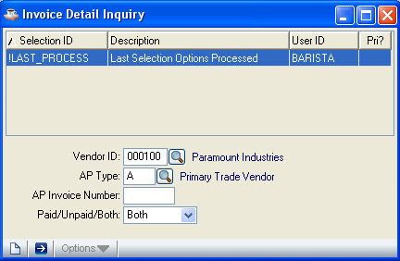

In the AP Type field...
This field appears when the Multiple AP Types parameter is set to Y.
- Enter the accounts payable type code that you want to use to view open invoice information.
- Click the Find button to select from a list of existing type codes.
- Click the close window button to return to the Vendor Master window.

In the AP Invoice Number field...
- Enter the number of the first invoice you want to see.
- Press Tab to view all the invoices.

In the Paid/Unpaid/Both field...
- Select Paid from the drop down box to display paid invoices only.
- Select Unpaid from the drop down box to display unpaid invoices only.
- Select Both from the drop down box to display all invoices.

Click the Run Process Button to get the invoice details.

The open invoices matching your entries are displayed. The final screen displays a vendor total.

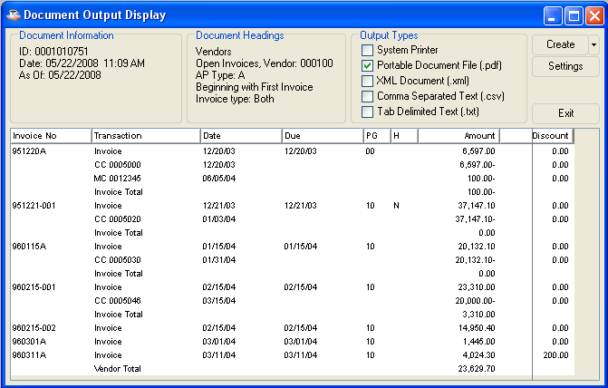

In the Invoice No field...
Display only. Shows the original invoice number of an invoice. Transactions that are posted to the invoice are shown below the invoice information.

In the Transaction field...
Display only. Shows the type of transaction that has occurred. These are the transaction types:

Invoice Original Invoice
CC Computer Check
MI Manual Invoice (created by manual check entry)
MC Manual Check
RC Check Reversal
Adjust Adjustment through Invoice Entry

The number after CC, MC or RC is the check number.

In the Date field...
Display only. Shows the original invoice entry date, check date or adjustment date, depending upon the type of transaction.

In the Due field...
Display only. Shows the date the invoice is due, as determined during the invoice entry process.

In the PG field...
Display only. Shows the payment group assigned to an invoice

In the H field...
Display only. Shows the code that signifies the hold status of the invoice.

Y The invoice is in a hold status and cannot be selected for automatic payment.
N The invoice is available for normal processing.
S The invoice was selected for payment through the payment selection process.

In the Amount field...
Display only. Shows the amount of the corresponding transaction. Where an invoice has more than one transaction, the total shown represents the total balance due on the invoice.

In the Discount field...
Display only. Shows the amount of discount that can be taken when the invoice is paid within the terms period.

In the Retention field...
This field is displayed only when the Retention parameter is set to Y.
Display only. Shows the amount of retention outstanding on this invoice.

In the Invoice Total field...
Display only. Shows the total balance due after the last invoice.

Purchase Address Maintenance
Use this option to add, delete, change or list vendor purchasing addresses. The information is used by the Purchase Order module when it is installed.

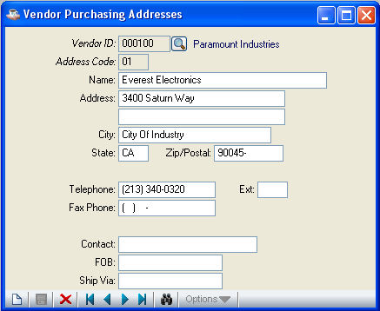

In the Address Code field...
- Enter a unique Address Code
- Click the Record Query button to select from a list of existing address records already assigned to this vendor.
- Click Close Window button to return to the Vendor Master window.

When you enter an existing address code, the address information associated with that code is displayed.

In the Name field...
• Enter the company or firm name that should appear on purchase orders for the address.

In the Address field...
- Enter 1 to 3 lines of address information.
- Press Tab to leave this field blank.

In the City field...
- Enter the city of the vendor up to 22 characters.
- Press Tab to leave this field blank.

In the State field...
- Enter 2 letter state code.
- Press Tab to leave this field blank.

In the Zip/Postal field...
- Enter the zip/postal code.
- Press Tab to leave this field blank.

In the Telephone field...
- Enter the telephone number with area code of the vendor.
- Press Tab to leave this field blank.

The punctuation for the area code and prefix is displayed.

In the Ext field...
- Enter an extension for the telephone of 1 to 4 digits.
- Press Tab to leave this field blank.

In the Fax Phone field...
- Enter the telephone number with area code of the vendor’s fax machine.
- Press Tab to leave this field blank.

In the Contact field...
• Enter the name of the purchasing contact for the purchasing location.
- Press Tab to leave this field blank.

In the FOB field...
- Enter up to 15 characters to identify the freight charge description.
- Press Tab to leave this field blank.

In the Ship-Via field...
- Enter the standard shipping method for this vendor, up to 15 characters in length.
- Press Tab to leave this field blank.

When you finish making entries to the fields,
- Click the Save button to save the record. The form is cleared in preparation for a new entry.
- Click the New button to begin a new address code
- Click the Delete button to delete the record.
- Click the Close Window button to return to the Vendor Master window

If the window is closed without saving the record, the module will issue a confirmation prompt:

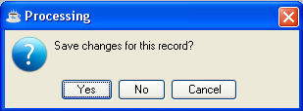

- Click Yes when you want to save the changes.
- Click No to return to the Vendor Master window without saving the record
- Click Cancel or Close Window button to return to the Vendor Master window

Comment Maintenance
Use this option to enter 1 to 99 lines of free-form comments about the vendor. Vendor comments are shown on the Purchase Order Entry, Invoice Entry, Manual Check Entry, and Vendor Maintenance Listing tasks. These comments are useful in tracking special purchasing or accounting information for a vendor.

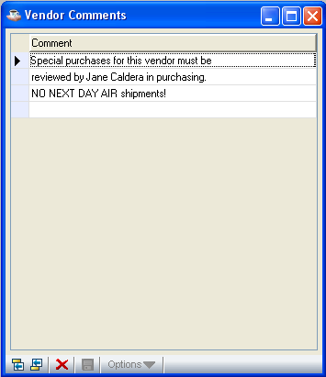

In the Comment field...
• Enter a comment of 1 to 48 characters in length.

In the Vendor Comments grid, use the Enter key to toggle between navigation mode and edit mode in a given cell. In navigation mode, the cell has a dotted outline. In edit mode, the contents of the cell are selected.

While in edit mode
• Use the Enter key to accept the edits and remain in the cell, toggling to navigation mode
- Use the Tab key to accept the edits and move to the next cell

While in navigation mode
- Use the Enter key to highlight the contents of the cell and perform edits (i.e., toggles to edit mode)
- Use the arrow or tab keys to move to different cells

After entering the comments;
- Click the Save button to save the record
- Click the Delete button to delete the currently selected grid row.
- Click the Close Window button to return to the Vendor Master window.

Receipt History Inquiry
This option is available only when the Purchase Order module is installed. Available in either summary or detail format, use the Receipt History Inquiry option to view information about the receipt status of purchase orders issued to a particular vendor or to compare vendor invoices with purchase order receipts. Only purchase orders that have items received are shown, however receipts are displayed regardless of whether an invoice is entered.

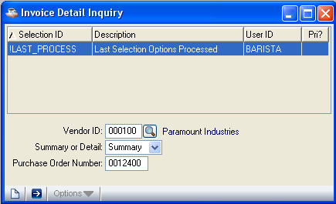

In the Summary Or Detail field...
- Select Summary from the drop down box to display purchase order information in summary. This is the default selection.
- Select Detail from the drop down box to display purchase order information in detail.

In the Purchase Order Number field...
- Enter the number of the first purchase order receipt that is to be displayed.
- Press Tab to view all purchase order receipts on file for the vendor.

Purchase order receipts matching your entries are displayed. The report displays a purchase total and a vendor total.

Summary Information
The summary format of the Receipt History Inquiry option shows the correlation of ordered, received and invoiced dollar amounts. No purchase order line item detail is displayed.

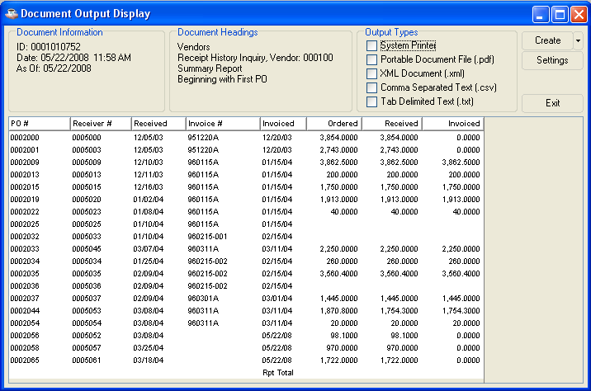

In the PO Number field...
Display only. Shows the number of the purchase order for the item requested.

In the Receiver Number field...
Display only. Shows the receiver number

In the Received Date field...
Display only. Shows the date that the purchase was made.

In the Invoice Number field...
Display only. Shows the number of the invoice.

In the Invoiced Date field...
Display only. Show the date of any invoice associated with the purchase order.

In the Ordered field...
Display only. Shows the value of the total order.

In the Received field...
Display only. Shows the value of goods received.

In the Invoiced field...
Display only. Shows the remaining value of items on the purchase order yet to be invoiced.

Detail Information
The detail format of the Receipt History Inquiry option shows detailed information about the items received against a purchase order.

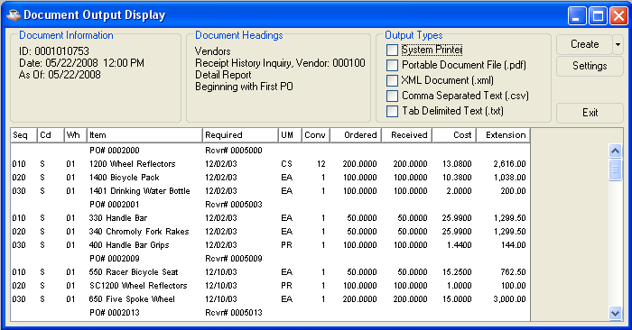

In the Seq field...
Display only. Shows the line number of the item on the purchase order.

In the Cd field...
Display only. Shows the line code of the item on the purchase order.

In the Whse Code field...
Display only. Shows the warehouse where the item is stored.

In the Item Number field...
Display only. Shows the identifying number and description for the item. The purchase order number the item requested is also displayed in this column.

In the Required field...
Display only. Shows the date that the item is required. The receiver number is also displayed in this column.

In the UM field...
Display only. Shows any unit of measure for the item.

In the Conv field...
Display only. Shows any conversion factor used for the item.

In the Ordered field...
Display only. Shows the amount ordered of the item.

In the Received field...
Display only. Shows the amount received of the item.

In the Cost field...
Display only. Shows the cost by unit for the item.

In the Extension field...
Display only. Shows the extended cost for the item.

Replenishment Parameters
When the Purchase Order Processing module is interfaced to Accounts Payable, you can use this option to maintain vendor/buyer replenishment information within the vendor master file. The Replenishment Processing parameter must be set to Y to access this option.

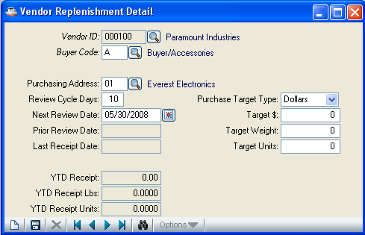

In the Buyer Code field...
- Enter a valid buyer code.
- Click the Find button to select from a list of existing buyer codes.
- Click the Close Window button to return to the Vendor Master window.

When you enter a valid buyer code, the information associated with the code is displayed.

In the Purchasing Address field...
- Enter a valid purchasing address code.
- Click the Find button to select from a list of existing address codes.
- Press Tab to leave this field blank.

In the Review Cycle Days field...
- Enter the desired minimum number of days between replenishment reviews for the vendor/buyer. A low number indicates frequent reviews; a high number means reviews should take place less often.
- Press Tab to accept the default cycle length that was established for the buyer code.

In the Next Review Date field...
- Enter the next scheduled review date for the vendor/buyer in the MMDDYY format.
- Click the Calendar button to select a date by using the calendar tool
- Press Tab to use the date calculated by the Purchase Order Processing module’s Replenishment Report update (Prior Review Date plus Review Cycle Days). Line point review is performed only on or after this date.

With a seasonal inventory, the buyer may want to advance this date to the next buying season. If the buyer is unable to perform the review on that date, change to an earlier date.

In the Prior Review Date field...
Display only. Shows the date of the most recent Replenishment Report update for the vendor/buyer.

In the Last Receipt Date field...
Display only. Shows the last date of a purchase order receipt from the vendor.

In the YTD Receipt $ field...
Display only. Shows the total dollar value of purchase orders received so far this year from the vendor/buyer.

In the YTD Receipt Weight field...
Display only. Shows the total weight of items received so far this year from the vendor/buyer.

In the YTD Receipt Units field...
Display only. Shows the total number of units received so far this year from the vendor/buyer.

In the Purchase Target Type field...
- Select Dollars from the drop down box for basing replenishment on dollar amounts.
- Select Weight from the drop down box for basing replenishment on weight amounts.
- Select Units from the drop down box for basing replenishment on unit amounts.
- Select No Target from the drop down box for no purchase target type.

In the Target $ field...
• Enter the minimum purchase order amount that qualifies for the vendor’s best pricing terms.

In the Target Weight field...
• Enter the minimum purchase order weight that qualifies for the vendor’s best pricing terms.

In the Target Units field...
• Enter the minimum purchase order quantity that qualifies for the vendor’s best pricing terms.

When you finish making entries to the fields,
- Click the Save button to save the record and form is cleared in preparation for a new entry.
- Click the New button to begin a new entry
- Click the Delete button to delete the current distribution type
- Click Close Window button to return to the Vendor Master window.

If the window is closed without saving the record, the module will issue a confirmation prompt:

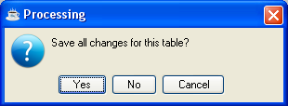

- Click Yes when you want to save the changes.
- Click No to return to the Vendor Master window without saving the record
- Click Cancel or Close Window button to return to the Vendor Master window

Accounts Payable Type Maintenance
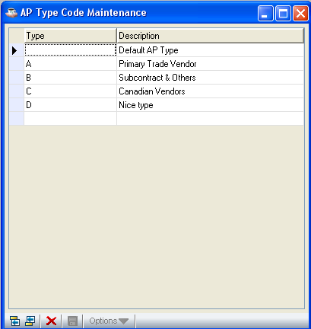
Accounts Payable Type Maintenance

Function
Use this task to define the accounts payable type codes. At least one accounts payable type code is required for normal module operation, regardless of the setting of the Multiple AP Types parameter. Multiple accounts payable types are used to separate vendor invoices and payments by vendor type. A list of all accounts payable codes is available.

n To access this task...

Select Accounts Payable Type from the Accounts Payable Maintenance Menu.

About the Fields

In the Type field...
• Enter a 2-character alphanumeric code to identify the accounts payable type.
- Click Close Window button to return to the Accounts Payable Maintenance Menu.

NOTE: You must define one standard default accounts payable type that must be “” (two blanks). This default must be defined regardless of how many other codes you have. Your module will not work properly without defining this standard default code.

In the Description field...
• Enter a description of 1 to 20 characters in length.

While in the grid, use the Enter key to toggle between navigation mode and edit mode in a given cell. In navigation mode, the cell has a dotted outline. In edit mode, the contents of the cell are selected.

While in edit mode
• Use the Enter key to accept the edits and remain in the cell, toggling to navigation mode
- Use the Tab key to accept the edits and move to the next cell

While in navigation mode
- Use the Enter key to highlight the contents of the cell and perform edits (i.e., toggles to edit mode)
- Use the arrow or tab keys to move to different cells

When you finish entering type codes,

- Click the Save button to save the record
- Click the Delete button to delete the AP Type in the currently selected grid row.
- Click the Close Window button to return to the Accounts Payable Maintenance Menu.

CAUTION: Do not delete accounts payable type codes already assigned to vendors or invoices that currently exist in the module. To do so causes data errors during accounts payable processing.

If the window is closed without saving the record, the module will issue a confirmation prompt:

- Click Yes when you want to save the changes.
- Click No to return to the Accounts Payable Maintenance Menu without saving the record
- Click Cancel or Close Window button to return to the AP Type Code Maintenance Window.

Distribution Code Maintenance
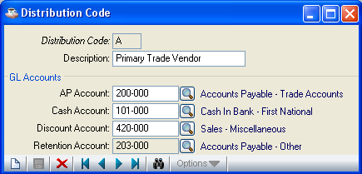
Distribution Code Maintenance

Function
Use this task to enter and maintain distribution codes. Codes are assigned in the Detail Information option of the Vendor Maintenance task. The distribution code associated with an invoice determines the accounts used for posting during the Invoice Register, Manual Check Register and Check Register update processes. Accounts are specified for accounts payable, cash, discounts and retention.

n To access this task...

Select Distribution Code Maintenance from the Accounts Payable Maintenance Menu.

NOTE: The distribution code can be changed in the Invoice Entry and Manual Check Entry tasks when the Multiple Distributions parameter is set to Y.

About the Fields

In the Distribution Code field...
- Enter a 2-character alphanumeric code to identify the distribution code.
- Click Record Query button to select a vendor id from a list of existing distribution code records
- Click the record navigating buttons; First Record buttonto view the first record, Previous Record buttonto view the previous record, Next Record buttonto view the next record and Last Record button to view the last distribution code record.
- Click the Close Window button to return to the Accounts Payable Maintenance Menu.

NOTE: You must define one standard default distribution code, that must be “ ” (two blanks). You must define this default regardless of how many other codes you have. Your module will not work properly if you do not define this standard default code.

When you enter a valid distribution code, the description and accounts associated with the code are displayed.

In the Description field...
• Enter a distribution code description of 1 to 20 characters.

In the AP Account field...
This field is accessible only when the General Ledger module is installed.
- Enter a valid general ledger account number to identify the accounts payable liability.
- Click the Find button to select from a list of existing GL Accounts

This account posts during the Invoice Register update process.

In the Cash Account field...
This field is accessible only when the General Ledger module is installed.
• Enter a valid general ledger account number to identify the cash account.
- Click the Find button to select from a list of existing GL Accounts

This account posts during the Check Register and Manual Check Register update processes.

In the Discount Account field...
This field is accessible only when the General Ledger module is installed.
• Enter a valid general ledger account number to identify the accounts payable discounts taken.
- Click the Find button to select from a list of existing GL Accounts

This account posts, if discounts are taken, when invoices are paid.

In the Retention Account field...
This field is accessible only when the Retention Account parameter is set to Y.
- Enter the account number of the retention payable account.
- Click the Find button to select from a list of existing GL Accounts

This account posts during the Invoice Register update process using the amounts entered in the Retention field during invoice entry.

When you finish entering distribution codes,

- Click the Save button to save the record and form is cleared in preparation for a new entry.
- Click the New button to begin a new distribution code entry
- Click the Delete button to delete the current distribution type
- Click Close Window button to return to the Accounts Payable Maintenance Menu.

CAUTION: Do not delete distribution codes already assigned to vendors or invoices that exist in the module. To do so causes errors during Accounts Payable processing.

If the window is closed without saving the record, the module will issue a confirmation prompt:

- Click Yes when you want to save the changes.
- Click No to return to the Accounts Payable Maintenance Menu without saving the record
- Click Cancel or Close Window button to return to the Distribution Code Maintenance Window.

Payment Group Maintenance
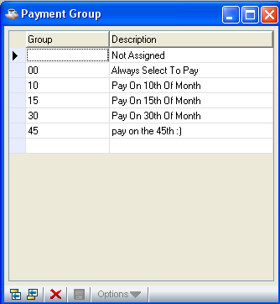
Payment Group Maintenance

Function
This task is used to define and maintain the payment group codes that are used to group vendors or invoices for automatic payment selection. For example, all vendors paid on the 15th may be assigned a payment group code with a description of “Payment on 15th.”

n To access this task...

Select Payment Group Maintenance from the Accounts Payable Maintenance Menu.

About the Fields

In the Payment Group field...
- Enter a 2-character alphanumeric code to identify this payment group.
- Click Close Window button to return to the Accounts Payable Maintenance Menu

NOTE: You must define one standard default payment group, that must be “ ” (two blanks). You must define this default regardless of how many other codes you have. Your module will not work properly if you do not define this standard default code.

In the Description field...
• Enter a description of 1 to 20 characters in length.

Payment group codes are assigned to vendors and invoices to be used in selecting invoices for payment.

Payment Group Code Examples
10 Pay on 10th of month
FB Freight bills
AS Always select to pay

(Codes are limited to 2-characters, with 20-character descriptions.)

While in the grid, use the Enter key to toggle between navigation mode and edit mode in a given cell. In navigation mode, the cell has a dotted outline. In edit mode, the contents of the cell are selected.

While in edit mode
• Use the Enter key to accept the edits and remain in the cell, toggling to navigation mode
- Use the Tab key to accept the edits and move to the next cell

While in navigation mode
- Use the Enter key to highlight the contents of the cell and perform edits (i.e., toggles to edit mode)
- Use the arrow or tab keys to move to different cells

When you finish entering payment group codes,

- Click the Save button to save the record
- Click the Delete button to delete the Payment Group Code in the currently selected grid row.
- Click the Close Window button to return to the Accounts Payable Maintenance Menu.

CAUTION: Do not delete payment group codes already assigned to vendors or invoices that exist in the module. To do so causes errors during processing.

If the window is closed without saving the record, the module will issue a confirmation prompt:

- Click Yes when you want to save the changes.
- Click No to return to the Accounts Payable Maintenance Menu without saving the record
- Click Cancel or Close Window button to return to the Payment Groups Maintenance Window.

Terms Code Maintenance
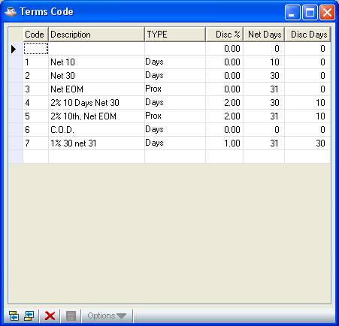
Terms Code Maintenance

Function
Use this task to create, modify, delete, inquire about or list terms codes used in invoice entry. You can assign each vendor a default terms code that determines the due date and discount due date (if applicable) for the vendor’s invoices. The terms code can be overridden in Invoice Entry.

n To access this task...

Select Terms Code Maintenance from the Accounts Payable Maintenance Menu.

About the Fields

In the Terms Code field...
- Enter a 2-character alphanumeric code to identify the terms code
- Click Close Window button to return to the Accounts Payable Maintenance Menu.

In the Description field...
• Enter 1 to 20 characters to describe the terms.

In the Type field...
• Select Days from the drop down box for terms that are based on a specific number of days from the invoice date.
- Select Prox from the drop down box for prox terms that are based on a specific day in the next month.

In the Discount % field...
• Enter the discount in percentage form offered with these terms.
- Press Tab to accept the default.

Discount % Example
• Enter 2.5 for a prompt payment discount of 2.5% (.025).

In the Net Day(s) field...
- Enter the number of days from the invoice date that the total amount of the invoice is due for a type Days terms code.
- Enter the day of the month (1 through 31) of the next month that the invoice is due for a type Prox terms code
- Enter 31 for prox terms that require payment on the last day of the following month

In the Discount Days field...
- Enter the number of days past the invoice date that a prompt payment discount may be taken for a type D terms code.
- Enter the day of the month before which the prompt payment discount may be taken for a type P terms code

For prox terms, the discount date is always the same date in each month.

While in the grid, use the Enter key to toggle between navigation mode and edit mode in a given cell. In navigation mode, the cell has a dotted outline. In edit mode, the contents of the cell are selected.

While in edit mode
• Use the Enter key to accept the edits and remain in the cell, toggling to navigation mode
- Use the Tab key to accept the edits and move to the next cell

While in navigation mode
- Use the Enter key to highlight the contents of the cell and perform edits (i.e., toggles to edit mode)
- Use the arrow or tab keys to move to different cells

When you finish entering terms code information,

- Click the Save button to save the record
- Click the Delete button to delete the Terms Code in the currently selected grid row.
- Click the Close Window button to return to the Accounts Payable Maintenance Menu.

If the window is closed without saving the record, the module will issue a confirmation prompt:

- Click Yes when you want to save the changes.
- Click No to return to the Accounts Payable Maintenance Menu without saving the record
- Click Cancel or Close Window button to return to the Terms Code Maintenance Window.

Buyer Code Maintenance
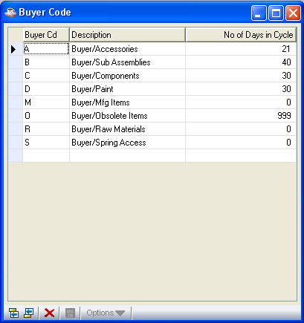
Buyer Code Maintenance

Function
Use this task to create, modify, delete, inquire about or list buyer codes used in vendor replenishment details through the Purchase Order module. You can assign each vendor a buyer code that determines the review cycle days that will be used to find next review date to use in vendor replenishment.

n To access this task...

Select Buyer Code from the Accounts Payable Maintenance Menu.

About the Fields

In the Buyer Cd field...
- Enter a 2-character alphanumeric code to identify the buyer code
- Click Close Window button to return to the Accounts Payable Maintenance Menu.

In the Description field...
• Enter 1 to 20 characters to describe the buyer code.

In the No of Days in Cycle field...
• Enter the number of cycle days

While in the grid, use the Enter key to toggle between navigation mode and edit mode in a given cell. In navigation mode, the cell has a dotted outline. In edit mode, the contents of the cell are selected.

While in edit mode
• Use the Enter key to accept the edits and remain in the cell, toggling to navigation mode
- Use the Tab key to accept the edits and move to the next cell

While in navigation mode
- Use the Enter key to highlight the contents of the cell and perform edits (i.e., toggles to edit mode)
- Use the arrow or tab keys to move to different cells

When you finish entering buyer code information,

- Click the Save button to save the record
- Click the Delete button to delete the Buyer Code in the currently selected grid row.
- Click the Close Window button to return to the Accounts Payable Maintenance Menu.

If the window is closed without saving the record, the module will issue a confirmation prompt:

- Click Yes when you want to save the changes.
- Click No to return to the Accounts Payable Maintenance Menu without saving the record
- Click Cancel or Close Window button to return to the Buyer Code Maintenance Window.

Recurring Invoice Entry
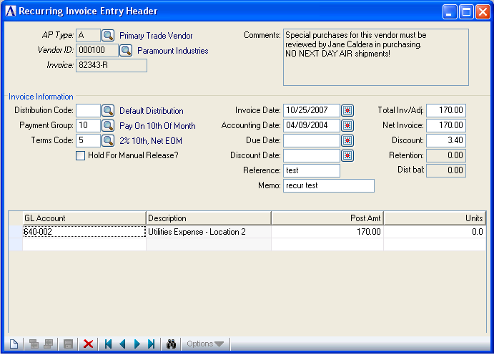
Recurring Invoice Entry

Function
Use this task to establish records of recurring bills or invoices that are processed each month. You enter recurring invoices much the same way standard non-recurring invoices are entered. Recurring invoice processing begins in each payment period with the printing of the Recurring Invoice Register. The update that follows places the recurring invoices in the standard Invoice Entry file so the remainder of the processing is done along with the regular payment period processing.

n To access this task...

Select Recurring Invoice Entry from the Accounts Payable Maintenance Menu.

About the Fields
Recurring invoices are identified by the combination of vendor number, accounts payable type (optional) and invoice number entered when the invoice is defined. The same data fields and procedures for the Invoice Entry task are also used for the Recurring Invoice Entry task, with the exception of the following two fields. For information on the other fields, refer to Invoice Entry.

In the Invoice No field...
• Enter an alphanumeric number of 1 to 6 characters (regular invoice entry allows ten).

The number of days from the first of the year is appended to the invoice number during the Recurring Invoice Register update process. When a recurring invoice remains in the Accounts Payable module more than one year, the suffix becomes the number of days plus 365.

Recurring Invoice Number Example
A recurring invoice with the number of 665544 is updated on January 31. During the update, it is numbered 6655440031. The same recurring invoice updated on February 28 creates an invoice numbered 6655440059. On March 30, the same invoice is numbered 6655440089. On January 31 of the next year, the invoice is numbered 6655440396. This creates a unique identity (invoice number and day of year) each month for a recurring invoice.

In the Invoice Date field...
• Enter the date the invoice is due.

Only the day of the month entered (not the month or year) is significant when recurring invoices are updated. A new invoice with the current month and year is created and entered into the regular invoice file.

Recurring Invoice Register
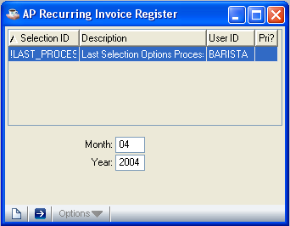
Recurring Invoice Register

Function
Print and update the Recurring Invoice Register monthly. After printing the register, verify the information and make corrections before updating. The update causes a copy of each recurring invoice to be transferred to the standard invoice entry file. There they are modified or deleted like any other invoice before printing and updating the Invoice Register.

n To access this task...

Select Recurring Invoice Register from the Accounts Payable Maintenance Menu.

About the Fields
In the Period field...
• Enter the desired accounting period for the report. Current period will be the default value

In the Year field...
• Enter the desired accounting year for the report. Current year will be the default value

The day component of the date is taken from the Invoice Date entered in the Recurring Invoice Entry task.

After entering the values;

- Click the Run Process button to run the register
- Click the New button to reset the date and year fields to default values
- Click the Close Window button to return to the Accounts Payable Maintenance Menu.

Printing
The Invoice Register will appear in the Document Output Display window. Select your desired output format and click the Create button:

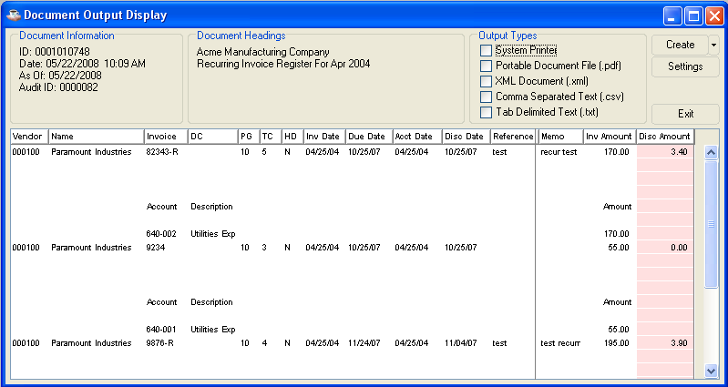

Any data shaded with pink in the Document Output window is at risk of truncation when the document is printed or saved in pdf format. Click and drag to adjust column sizes until no pink shading remains. If the report is too large to adjust in this manner, save it in one of the disk file formats (xml, csv, txt) in order to prevent data loss.

Choose your Output Type and click the Create button. After the file is created or printed, click the Close Window button to close the Document Output Display window.

If General Ledger is installed and the GL Posting Parameter is set to Y, you’ll be presented with a second Document Output Display window. This GL recap lists general ledger postings, in account number order, created during the Invoice Register.

As with the register, choose your Output Type and click the Create button. After the file is created or printed, click the Close Window button or press ctl-F4 to close the Document Output Display window.

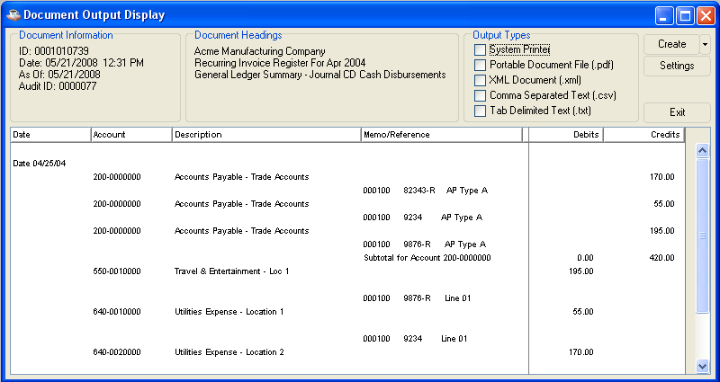

When the printing is complete the module issues a confirmation box:

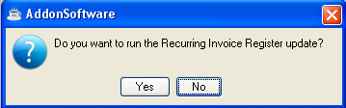

- Click Yes if the register printed correctly and balances to the totals for recurring invoices.
- Click No or Close Window button to return to the Accounts Payable Maintenance Menu without updating the Recurring Invoice Register

Updating
During the update, an invoice is added to the Invoice Entry file for each defined recurring invoice. Refer to the Recurring Invoice Entry task for information about how the recurring invoice number is assigned. When the update process is completed a message box will be displayed

Parameter Maintenance
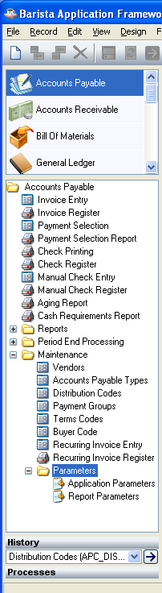
Parameter Maintenance Menu

Function
The Accounts Payable parameters determine the way the module processes business accounts. The parameters in Parameter Maintenance are divided into two options: Application Parameters, and Report Parameters .Once the Accounts Payable module is in operation, consult your AddonSoftware dealer before making any changes.

n To access this task...

Select Parameters from the Accounts Payable Maintenance Menu.

About the Parameter Maintenance Options
Use the Application Parameters option to create, modify, delete or display the Accounts Payable module parameters. When you enter parameters for the first time, the Report Parameters option is accessed after the module parameters are entered.

Use the Report Parameters option to define and maintain company names and addresses that use the module. You will access this information to export 1099 Form information and for reference.

Application Parameters
You must define the application parameters as part of the module installation, and generally these are not modified later. The parameters are used throughout the Accounts Payable tasks to control how the module functions. When you are changing the parameters without the assistance of your dealer (avoid unless absolutely necessary), study the parameter information in the Installation section before making any changes.

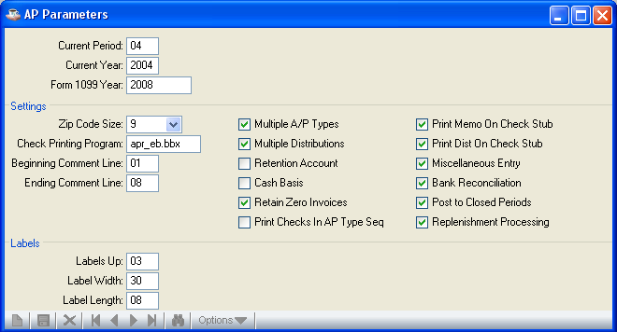
Application Parameters

When you select Application Parameters from the menu, the screen displays the current parameters.

In the Current Period field...
• Enter the current accounts payable period.

This number represents the current fiscal period in which the Accounts Payable module is operating. During the conversion process, it is first set to the accounting period for the Accounts Payable module to begin operation. This number is incremented by the Period End Update task. It is not normally changed after the module is in live operation.
In the Current Year field...
• Enter the current accounting year for the Accounts Payable module; that is the calendar year when the current fiscal year began. The accounting year is not necessarily the same as the calendar year.

When the General Ledger module is installed, the Accounts Payable current year should coincide with the Current Year parameter in the General Ledger module. The only exception occurs when the year-end process has been run for Accounts Payable and not for the General Ledger.

In the Form 1099 Year field…
- Enter the Form 1099 year which will be used in Form 1099 Data Exporting and closing 1099 forms.

In the Zip Code Size field...
• Enter the size of the zip or postal code.

If this parameter is changed after the module is in operation, the zip/postal codes must be re-entered to make them appear in the correct format.

In the Check Printing Program field…
- Enter the name of the check printing program.

In the Beginning Comment Line field…
- Enter the number of the first vendor comment line to view during invoice entry.

In the Ending Comment Line field…
- Enter the number of the last vendor comment line to view during invoice entry. Eight lines are available for viewing in each window. If more than eight lines are set up, additional windows will open when <Enter> is pressed until all lines are viewed.

In the Multiple A/P Type field...
- Check the Multiple A/P Type box to use multiple accounts payable types.
- Uncheck the Multiple A/P Type box if categorization for vendors is not required.

This parameter provides a way to segregate accounts payable invoices into multiple types used in payment selection and processing. Accounts payable types can be used to indicate separate divisions, departments or categories of vendors.

NOTE: When this parameter is set to Y, you may also set a parameter to print accounts payable checks in accounts payable type sequence (refer to the Print Checks in AP Type Seq field).

In the Multiple Distribution field...
- Check the Multiple Distribution box to use multiple distributions.
- Uncheck the Multiple Distribution box if the company has one primary accounts payable liability and cash account.

Use this parameter to easily post invoices to separate accounts payable liability accounts and to post payments to specific cash accounts. This is accomplished by creating multiple accounts payable distribution codes and associating them with each invoice and payment processed by the module.

In the Retention Account field...
- Check the Retention box to activate accounts payable retention for this company.
- Uncheck the Retention box if you do not want to use accounts payable retention.

You can withhold payment for a specific amount on a vendor’s invoice, as in the case of a job-cost environment where the subcontractors on a job are not completely paid until the job is complete. The amount withheld is called retention. This amount is separated from the primary amount in a retention account when invoices are updated during the Invoice Register update process. The retention amount (if present) is displayed in the Payment Selection and Manual Check tasks and excluded from payment until the original amount of the invoice is paid.

In the Cash Basis field...
This field in only accessible when the Retention Account field is N.
- Check the Cash Basis box to operate Accounts Payable on a cash basis.
- Uncheck the Cash Basis box to operate Accounts Payable on an accrual basis. This field automatically defaults to N when Retention Accounts field is Y. Refer to System Parameters in the Installation section for more information.

When you operate the module on a cash basis and the General Ledger module is installed, the general ledger is posted only during the Check Register update process (for both computer printed and manual checks). All the functions of the Accounts Payable module are available for use regardless of the Cash Basis setting.

In the Retain Zero Invoices field...
- Check the Retain Zero Invoices box to prevent zero balance invoices from being removed from the open invoice file during period end processing.
- Uncheck the Retain Zero Invoices box to remove all invoices with a zero balance.

This parameter should be set to Y when you anticipate the need to print the Purchase Journal for a closed accounts payable period. If zero balance invoices are retained, they can be purged by the Zero Balance Invoice Report/Purge task

In the Print Checks In AP Type Seq field...
This parameter is designed for use when the Multiple AP Types parameter is set to Y and there are separate banks for each accounts payable type.
- Check the Print Checks in AP Type Seq box to print checks in accounts payable type sequence.
- Uncheck the Print Checks in AP Type Seq box if you wish to print checks in vendor number sequence.

In the Print Memo On Check Stub field...
- Check the Print Memo on Check Stub box when you want invoice memo to print on the check stub.
- Uncheck the Print Memo on Check Stub box to omit printing of the invoice memo.

In the Print Dist on Check Stub field...
- Check the Print Dist on Check Stub box when you want the general ledger expense distribution for the invoice to be printed on the check stub.
- Uncheck the Print Dist on Check Stub box to omit the expense distribution from the check stub.

This parameter should be set to Y when the General Ledger module is installed and you want to print distribution on checks. If the General Ledger is not installed, or not interfaced with AP, this field is defaulted to N and cannot be changed.

In the Miscellaneous Entry field...
- Check the Miscellaneous Entry box to allow a 10-character entry to each distribution in the Invoice Entry and Manual Check Entry tasks.
- Uncheck the Miscellaneous Entry box to disallow a miscellaneous entry.

In the Bank Reconciliation field...
This field is accessible only when the General Ledger module is installed.
- Check the Bank Reconciliation box to create postings to the Bank Reconciliation module.
- Uncheck the Bank Reconciliation box if you are not using the Bank Reconciliation module.

In the Post to Closed Periods field...
This field is accessible only when the General Ledger module is installed.
- Check the Post to Close Periods box when you want to allow entry of invoices and manual checks with accounting dates that fall within a closed general ledger period.
- Uncheck the Post to Close Periods box if you want to prevent this type of entry. The module issues a warning message during the Invoice Entry, Manual Check Entry, Check Printing and Recurring Invoice Register updates when accounting dates fall within a closed period.

In the Replenishment Processing field...
- Check the Replenishment Processing box to allow the automatic replenishment feature to be activated.
- Uncheck the Replenishment Processing box to ignore this feature.

The automatic replenishment feature helps the purchasing department purchase more efficiently, improve sales margins, decrease paper and reduce inventory levels.

Portions of the automatic replenishment feature are set up in several different AddonSoftware modules, because the feature draws information from a variety of sources. When you choose to use automatic replenishment, enter buyer code and stocking vendor information into the Inventory Maintenance, Purchase Order Processing Vendor Maintenance, and Accounts Payable Vendor Maintenance tasks as explained in the Installation section of this manual and the Purchase Order Processing and Inventory Control manuals.

In the Labels Up field...
• Enter the number of labels across the page.

The Labels parameters allow formatting vendor mailing labels to match existing label stock. The Labels Up quantity multiplied by the Labels Width quantity must not exceed 130.

In the Label Length field...
• Enter the number of lines from the top of one label to the top of the next label. There are six lines per printed inch.

In the Label Width field...
• Enter the number of characters from the left position of one label to the left position of the next label.

The standard width is ten characters per inch. The Labels Up quantity multiplied by the Labels Width quantity must not exceed 130.

When changes to the fields are made,
- Click the Save button to save the Application Parameters
- Click Close Window button to return to the Accounts Payable Maintenance Menu.

Report Parameters
Use this option to enter and maintain the name, address and company identification information of each company using the Accounts Payable module. The information is used for reference and for exporting 1099 Form data.

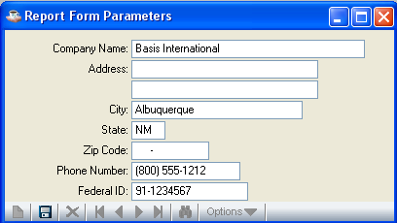

In the Company Name field...
• Enter the name of your company as it is to appear on the 1099 Forms.

In the Address field...
• Enter up to two lines of address information.

In the City field...
• Enter the city up to 22 characters.

In the State field...
• Enter 2 letter state code.

In the Zip Code field...
• Enter the zip/postal code.

In the Phone Nuber field...
• Enter the telephone number with area code of the vendor.

In the Federal ID field...
• Enter the federal ID number for this company as it is to appear on the 1099 Forms.

When you finish making changes to the fields:
- Click the Save button to save the Report Parameters
- Click Close Window button to return to the Accounts Payable Maintenance Menu.

